 

**MIDDLE EAST TECHNICAL UNIVERSITY**

**DEPARTMENT OF ELECTRICAL & ELECTRONICS ENGINEERING**

**EE447 LABARATORY TERM PROJECT**

**Battleship Game Console**

**Final Report**

Aycan BEYENİR

Middle East Technical University

Department of Electrical and Electronics Engineering

Ankara, Turkey

[aycan.beyenir@metu.edu.tr](mailto:aycan.beyenir@metu.edu.tr)

2030328

İrem COŞKUN

Middle East Technical University

Department of Electrical and Electronics Engineering

Ankara, Turkey

[irem.coskun_01@metu.edu.tr](mailto:irem.coskun_01@metu.edu.tr)

2030419

Table of Contents

1 Introduction 2

2 Game Description 2

3 Modules 4

3.1 ADC SUBMODULE 5

3.2 20 Sec Timer Submodule 6

3.3 Screen Driver Subsystem 7

3.4 Push Button Control Submodule 9

3.5 MEMORY MAP 10

3.6 CURSORS 12

4 Main System 12

4.1 System Start 12

4.2 Player 1’s Turn 13

4.3 Player 2’s Turn 14

5 Equipment List 15

6 Conclusion 15

7 References 15

8 Appendix 1 16

9 Appendix 2 20

10 Appendix3 24

11 Appendix 4 28

12 Appendix 5 31

# Introduction

The aim of this project is to design and implement a simpler version of the “Battleship” game. For this purpose, TM4C123G board, 2 potentiometers and a NOKIA 5110 LCD screen will be used. The knowledge gained from previous experiments will be used for implementation. For example, an ADC module is needed to identify the different inputs changing using a potentiometer. This game is played by two users. One user will be the one who deploy ships. However, the difference between the normal game is that deployer user can also deploy civilian ships in addition to battleships. Also, the other player is just an attacker. The only aim of the other player is to find the battleships and bomb them by placing the mines. This game challenges the visual memory since the attacker player, which is going to be mentioned as Player2 now on, have half a second to see the positions of the ships that deployer player, Player1, positioned. There are some restrictions for gameplay area which includes the cursor, target and play area pixel sizes. Serial Peripheral Interface is going to be used to transmit the data from the board to screen. Our board TM4C123G had built in SSI modules and these modules are going to be configured using SPI protocol. This final report shows the description of work done and corresponding Assembly codes for the purpose of this game. Previous experience gained during the laboratory sessions used also, new modules of the TMC4C123G board used during the development phase of the game.

# Game Description

Game has some restriction for playing. It can be seen as a two-player game, but it actually is mostly for player two. Player two is the one who is going to win or lose at the end. So, Player 1 should add ships to the screen, at least one of them should be battleship. After that when Player 1 is happy with its selection, presses a button to clear screen. Then, Player2 presses a button to see the ship positions for 0.5 seconds then has 20 second for positioning the mines in correct places. The second player can add up to 4 mines. When the time is passed the screen shows the result. If the player2 destroys all the battleships when no civilian ships destroyed screen shows a victory message if not, screen shows a humiliating message. Figure 1 shows the state diagram of the system. For our game it shows either “YOU WIN!!!” or “LOSER” on the screen at the end of the game. Player 1 and Player 2’s turns also visible on the screen when the turn passes to other player.

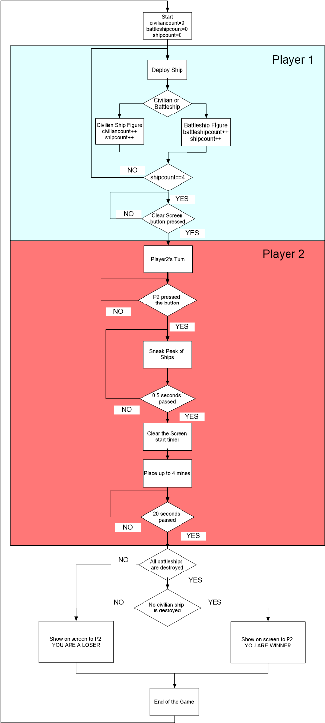

Figure 1: State Diagram for Battleship console game

# Modules

The key of designing complex system is dividing the operations into submodules. This division simplifies the design process and makes it easier to work on the project as a team. Hence in this project we divided the project into 8 clearly defined submodules. These submodules will be examined briefly in the next part. Figure 2 below shows a block diagram of submodules and their connections.

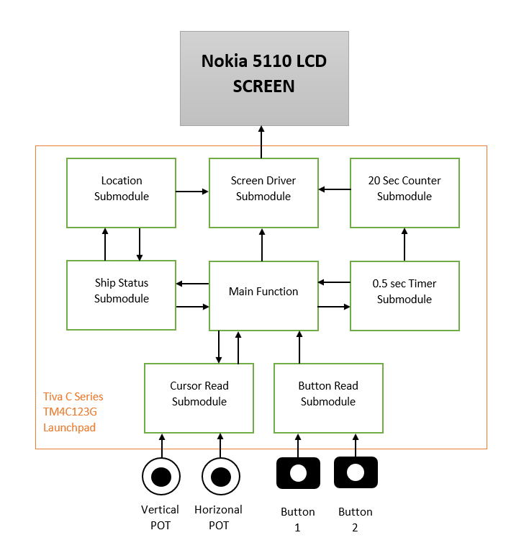

Figure 2: Block diagram of the system

Setup of our system can be seen below in Figure 3. For easier operation we connected potentiometers into a board. Potentiometers are our joysticks and buttons on the TIVA board are our buttons for operations. For initializing the game built-in RESET button is going to be used.

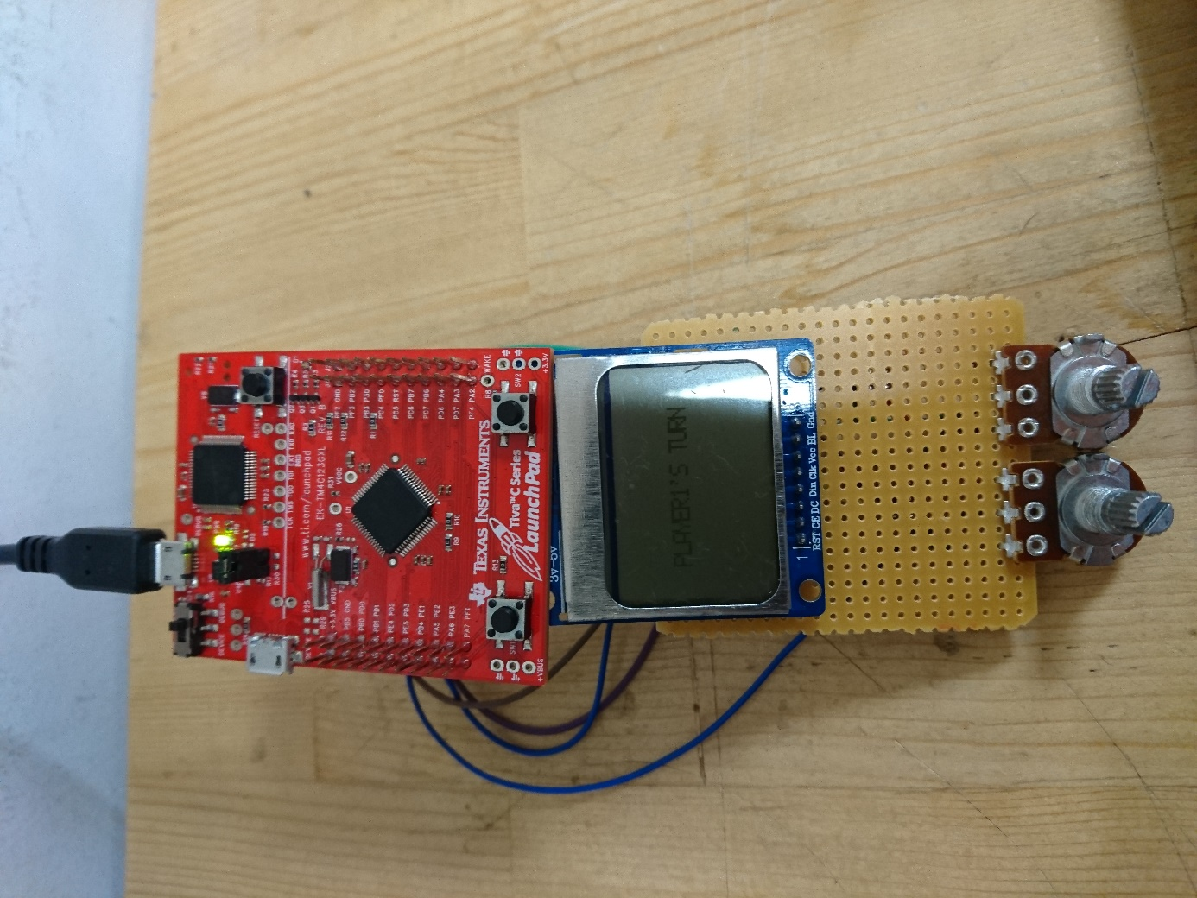

Figure 3: Our setup for battleship game console

## ADC SUBMODULE

ADC submodule is used in order to receive joystick movements. Two potentiometers are connected to AIN1 and AIN2 ports which are PE1 and PE2. First initialization of this system has been done. Steps for ADC initializations are as follows:

1. ADC clocks for ADC1 and ADC0 are turned on.
2. GPIO clock for Port E turned on.
3. PE1 and PE2 DEN disabled while AMSEL enabled.
4. ADC1 and ADC0 sequencer 3 disabled for configuration and software trigger selected for both.
5. ADC0 SSMUX3 configured in order to read AIN2.
6. ADC1 SSMUX3 configured in order to read AIN1.
7. Averaging registers on both ADC’s are set for 4x oversampling to reduce faulty readings.
8. Sample sequencers of both ADC’s enabled for enable sampling.

ADC initialization code can be found in Appendix 1.

After initialization ADC reading are taken from two different subroutines named as ADC_READ_SHIP and ADC_READ_CURSOR. The working principle of these two subroutines are same but since we have different sizes for cursor and ships the calculation of address operation differs. The operation is as follows:

1. Sampling initiated by setting PSSI register.
2. Sampling completion waited by checking RIS register.
3. Readings are taken from ADC0_SSFIFO3 and ADC1_SSFIF03.
4. Readings of different FIFOs gives X and Y data ranging from 0x000 to 0xFFF.
5. ISC flag cleared.
6. X and Y data values are loaded in different registers, so computation operation done on them in order keep ship or cursor in the game field.
7. These submodules return R4 keeping Ydata and Xdata. Ydata and X data keeps pixel values.
8. Least significant 4 bits of R4 shows X data and bits 3-7 shows Ydata.

ADC_READ_SHIP and ADC_READ_CURSOR codes can be found in Appendix 1.

We configured our ADC’s for oversampling in order to reduce unwanted glitches on screen. Also, we keep the data in a register so that by calling this submodule the value in this ADC can be found as X Y pixel location. These pixel locations are going to be used in writing functions.

## 20 Sec Timer Submodule

This submodule is responsible for the adjustment of the play time of the Attack stage. In the attack stage player 2 have 20 seconds play time prior to sneak peak of ship placement. During the game this submodule sends remaining time to the Screen Driver Submodule with 1 second resolution. Hence in this submodule the game time is hold by configuration of 1 second timers which run 20 times. Timer module gave interrupt in every second and the new time is sent to Screen Driver Submodule. At the end of 20th run when the game time ends, the end of game signal is sent to main function to finish the game.

20 second timer is going to be used to count downward on left top corner for the second player. For this purpose, we used SysTick timer. Systick timer interrupts in every second to visualize the remaining time. First Systick_timer should be configured. Also, a new submodule added to “startup.s” file. So, every time Systick interrupt occurs our code branches and links to our timer module.

Initialization of SysTick timer made after second player starts to play.

Systick timer initialization is as follows:

1. SysTick timer disabled during setup by setting 0 to NVIC_ST_CTRL.
2. A Reload_Value(corresponds to 1 second) loaded to NVIC_ST_RELOAD and NVIC_ST_CURRENT.
3. NVIC_ST_CTRL is set to 11 to enable the timer and interrupts.
4. Also, a counter value 21 loaded into R9 register.

The submodule which called when SysTick interrupt occurs works as follows:

1. First a flag set in which is going to keeps the condition if second digit printed or not.
2. Checks the R9 register in order to understand if counting ends or not.
3. If R9 is 0, disables SysTick timer and branches to end of the operation.
4. If R9 is not 0, subtract the R9 and visualizes the first and second digit on the top right corner of the screen.

The remaining times first and second digit found by making appropriate computations. After that, the value compared with the values ranging from 0 to 9. Moreover, branches the corresponding writing operation in order to visualize the correct number pixels. Every number is written pixel by pixel. write(number) operations are written individually for every number.

Appendix 2 shows Assembly codes for SysTick timer initialization and our Systick timer submodule.

SysTick timer interrupt preferred for this operation in order to do counting backwards and other operations simultaneously. Figure 6 below shows the 20 sec timer.

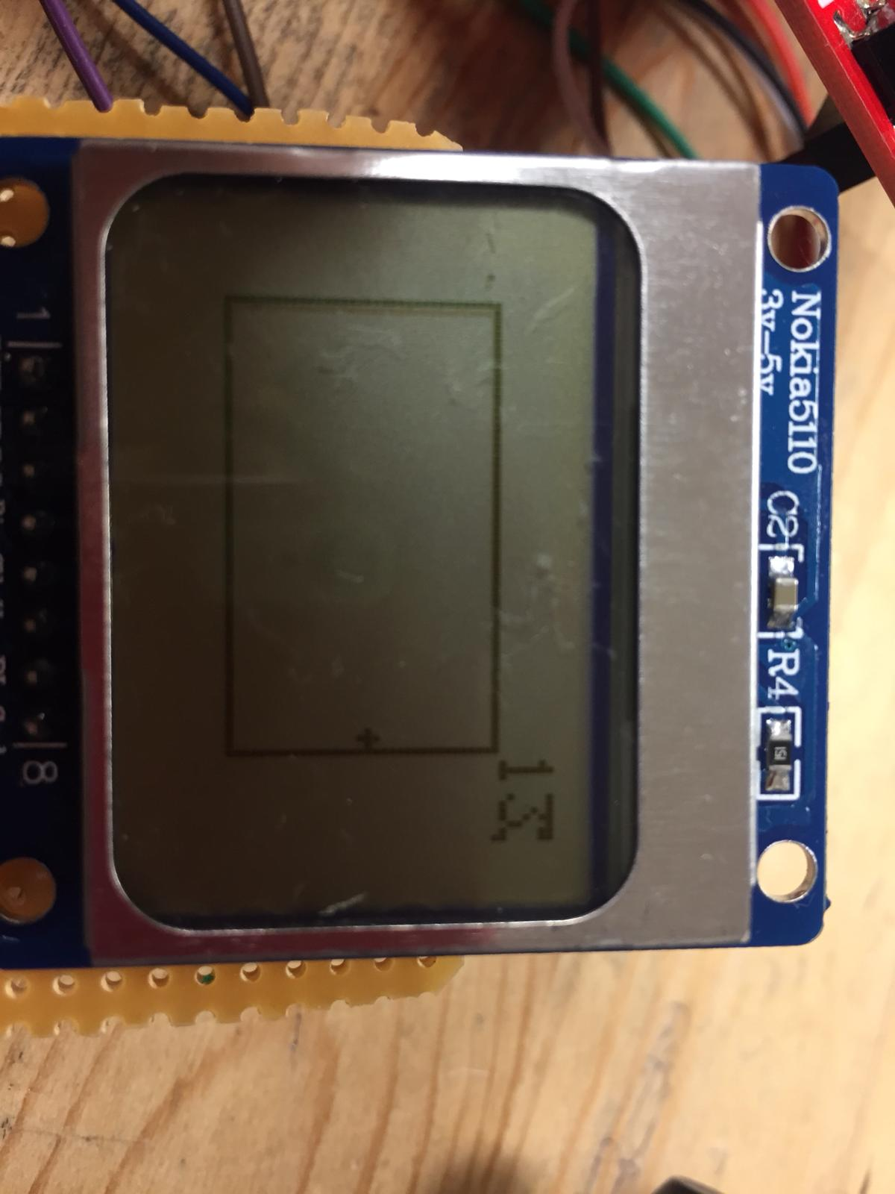

Figure 4: Screen with timer on top right corner

## Screen Driver Subsystem

In the development phase of the Battleship Game Console, using NOKIA 5110 LCD Screen is one of the most challenging task we had faced. In development, we aim to obtain fast and glitch free visual data in the screen. In the following part of this section we would explain how we initialized and used Tiva Board for proper operation and provide necessary algorithms and codes for clear explanation.

In order to have a functioning screen, 3 separate configurations are required [1]. For the sake of simplicity corresponding initialization codes are provided in Appendix 2. In the first step initialization of corresponding GPIO ports are done. For GPIO initialization we have 5 pin connections, with two different characteristics. First 3 pins (PA2, PA3, PA5) are SPI pins which governed by the SPI module on the TM4C123. Other two pins are external control pins of the screen (RESET and Data/Command). The initialization configuration for corresponding pins can be observed in Table 1.

Table 1: Initialize configuration of screen connections

|  |  |  |
| --- | --- | --- |
| SPI Pins  PA2 PA3 PA5 | GPIO_PORTA_DIR | All pins are set to output |
| GPIO_PORTA_DEN | All pins are digitally enabled |
| GPIO_PORTA_AMSEL | Analog function disabled |
| GPIO_PORTA_AFSEL | Alternate function enabled |
| GPIO_PORTA_PCTL | Pins connected to SSI interface |
| External  control Pins  PB0 & PB1 | GPIO_PORTB_DIR | All pins are set to output |
| GPIO_PORTB_DEN | All pins are digitally enabled |
| GPIO_PORTB_AFSEL | Alternate functions are disabled |

In the second step the internal SPI module of TM4C123 must be configured. In this configuration TM4C123 is used as master. In the connection between screen there is no acknowledge signal so there is no need to configure Rx port. The SPI configuration we used in this console can be observed in Table 2.

Table 2: SPI configuration for NOKIA 5110 Screen

|  |  |
| --- | --- |
| SSI0_CC | System clock is chosen (80MHz) |
| SSI0_CPSR | Clock prescale is set to 2 (80MHz => 40MHz) |
| SSI0_CR0 | Freescale SPI Frame Format  8-bit data  Serial Clock Rate = 10 (40Mhz => 4MHz) |

In the final phase, after all the hardwire connections are done and ports are initialized, the display is configured by following the steps provided in datasheet of PCD8544 NOKIA 5110 display [2]. The configuration steps are provided below.

* 100ms RESET (Active low) signal is send
* Command mode is activated by setting D/C pin to low
* Power ON, Vertical operation mode activated, and Extended command mode (H) activated, with (0x21) signal
* Vop Value is set to 0xBF
* Temperature value is set to 0x05
* Voltage bias value is set to 0x13
* Extended command mode is deactivated (0x20)
* Normal display mode is select (0x0C)

After the initialization phase of the screen, which shown in previous part, is completed, the screen is ready to receive commands, text, and images to be displayed. To send our visual information we wrote subroutine “DATA_WRITE” and to adjust the location of the data going to be written we wrote subroutine “ADDRESS_CHANGE”. Since, in most parts of the main code these subroutines are widely used, it is necessary to write these routines with minimum impact to the branched code. Hence both subroutines take their command from register R4 and returns no value to main code.

To briefly explain the operation of the “DATA_WRITE”; when called, this subroutine takes least significant byte of the R4. After receiving R4, controls status register of the SSI (SSI_SR), as if there is any empty location in Transmit FIFO. If FIFO is full, waits until any empty spot is present. If FIFO is not full, sends least significant byte of R4 to the data register of SSI. After writing the corresponding value to FIFO, ends its operation and returns to the address stated by link register.

The “ADDRESS_CHANGE” subroutine is written for adjusting the memory address of the screen. In NOKIA screen 84 horizontal (X) and 48 vertical (Y) pixels are present. On the other hand, vertical pixel bits are organized as 8bit pixel blocks which means there are only 6 vertical address. In normal operation the screen increments its address after every received data. However, this addressing mode is very low and has no flexibility. Hence for our operation we need to control these 84x6 addresses. For that in “ADDRESS_CHANGE” subroutine we take address data from the R4 register in a special configuration. The least significant byte of the R4 is reserved for X data and second byte is reserved for Y data. This organization is shown in Figure 4.

|  |  |  |  |  |  |  |  |
| --- | --- | --- | --- | --- | --- | --- | --- |
| 31 | 24:23 | | 16:15 | | 8:7 | | 0 |
| 0000.0000 | | 0000.0000 | | YYYY.YYYY | | XXXX.XXXX | |

*Figure 4: Bitmap configuration of R4 data input*

To briefly explain the operation of the “ADDRESS_CHANGE”; when called, this subroutine first makes Data/Command pin low to indicate it will send a command. Then takes the R4 value and extracts Y and X values from the R4. Before sending these values, controls status register of the SSI (SSI_SR), as if there is any empty location in Transmit FIFO. After FIFO became available, sends corresponding X and Y address values one by one to the screen. Before finishing its operation, this block needs to convert its D/C pin to high for forthcoming data write commands. Hence after predetermined delay, sets D/C pin to high and ends its operation and returns to the address stated by link register.

## Push Button Control Submodule

During the game push buttons on TIVA board will be used regularly. Push buttons are responsible of skipping the screen messages, deploying ships, place mines and end the operation for first player. Push buttons are connected to PF0 and PF4 pins internally. So, first it is necessary to initialize PF0 and PF4 ports. Initialization for F ports is as follows:

1. Activate RCGCGPIO clock for portF.
2. Unlock PortF.
3. GPIO_PORTF_CR_R enable Port access by loading 0xFF to this memory.
4. Disable analog function from AMSEL, enable digital function from DEN.
5. Disable alternate functions from PCTL.
6. Set direction register PIO_PORTF_DIR_R for PFO and PF4 input.
7. Enable pull-up resistor of PF4 and PF0 from PUR.

After initialization we needed to read the data regularly. So, for the sake of simplicity we wrote a PortF_Input subroutine. Which only takes the data from GPIO_PORTF_DATA_R and AND it with 0x11 in order to only have PF0 and PF4 registers. This value is loaded to R0 so this can be used for other submodules. R0 is 0x10 for when SW1 pressed and 0x01 when SW2 pressed. They are active high so when none of the buttons pressed R0 is 0x11. Figure 5 below shows the push buttons on TIVA board.

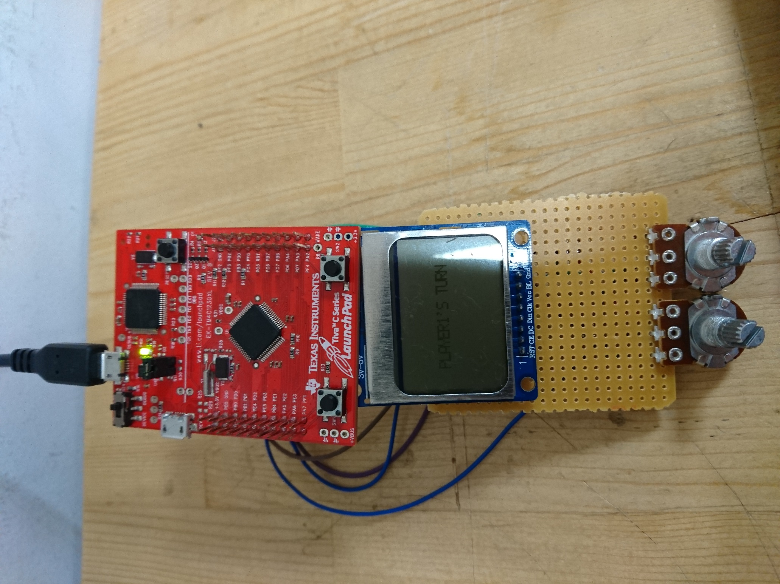

Figure 5 Built-in push buttons on TIVA TM4C123G board

## MEMORY MAP

Design of a multiple input and multiple scenario game forces us to follow various data and their real time comparison. This kind of task is impossible if we only use the 13 register in the core of the ARM. To cope with this amount of data we used SRAM of TM4C123. This memory block provides 32Kbyte of memory area for us. As shown in Table 3, we used this memory area for various operations. The corresponding code of “MEMORY_MAP” is provided in Appendix 4.

Table 3: Corresponding locations and purposes of memory blocks

|  |  |  |
| --- | --- | --- |
| Memory Name | Address | Purpose |
| EMPTY_FIELD | 0x20000400-  0x200005F7 | Holds an empty playfield map for clear screen cases |
| PLAYFIELD | 0x20000600-  0x200007F7 | Holds the ships location on a map. In deployment phase this screen is shown in screen |
| MINEFIELD | 0x20002000-  0x200021F7 | Holds the mine location on a map. In attack phase this screen is shown in screen |
| SHIP_EMPTY  SHIP_CIVIL  SHIP_BATTLE | 0x20000800-  0x20000817 | Holds bitmaps for empty ship, battleship and civilian ship |
| CURSOR  MINE | 0x20000818-  0x2000081D | Holds bitmaps for mine cursor and mine |
| OLD_SHIP_LOC_X  OLD_SHIP_LOC_Y | 0x20001000  0x20001001 | Saves the last location of the ship cursor. Have important role in cursor movement. I will be further investigated in Ship cursor section. |
| OLD_CURSOR_LOC_X  OLD_CURSOR_LOC_X | 0x20001002  0x20001003 | Saves the last location of the mine cursor. Have important role in cursor movement. I will be further investigated in Ship cursor section. |
| SHIP_MEMO | 0x20001100  0x20001149 | Holds locations of placed ships. First word works as a pointer. It holds the address of incoming ship memory |
| MINE_MEMO | 0x20001150  0x20001199 | Holds locations of placed mines. First word works as a pointer. It holds the address of incoming mine memory |
| GP_MEMORY | 0x20006000-  0x200060FF | Reserved for general purpose memory usage. |

In this memory block one of the most important memory addresses are “SHIP_MEMO” and “MINE_MEMO” blocks. These blocks are used for saving the Y.X location of the ships and mines. The data saved in these blocks have crucial importance when we determine the winner and loser. To obtain best performance from this memory space we use pointer approach. The first word of each memory space holds the pointer address of next used memory space. This approach gives us flexibility in ship and mine number. With this approach we can place up to 10 ships and mines. On the other hand, due to 20 second limitation in attack phase, code blocks internally limit ship and mine number.

Other big blocks of memory are 3 field maps. Empty field, playfield and minefield holds invaluable visual information. Despite they do not have any impact on calculations, these blocks have important role in the visualization of the game. In Figure 6 and Figure 7 on screen shots of these maps are shown with ship and mine symbols.

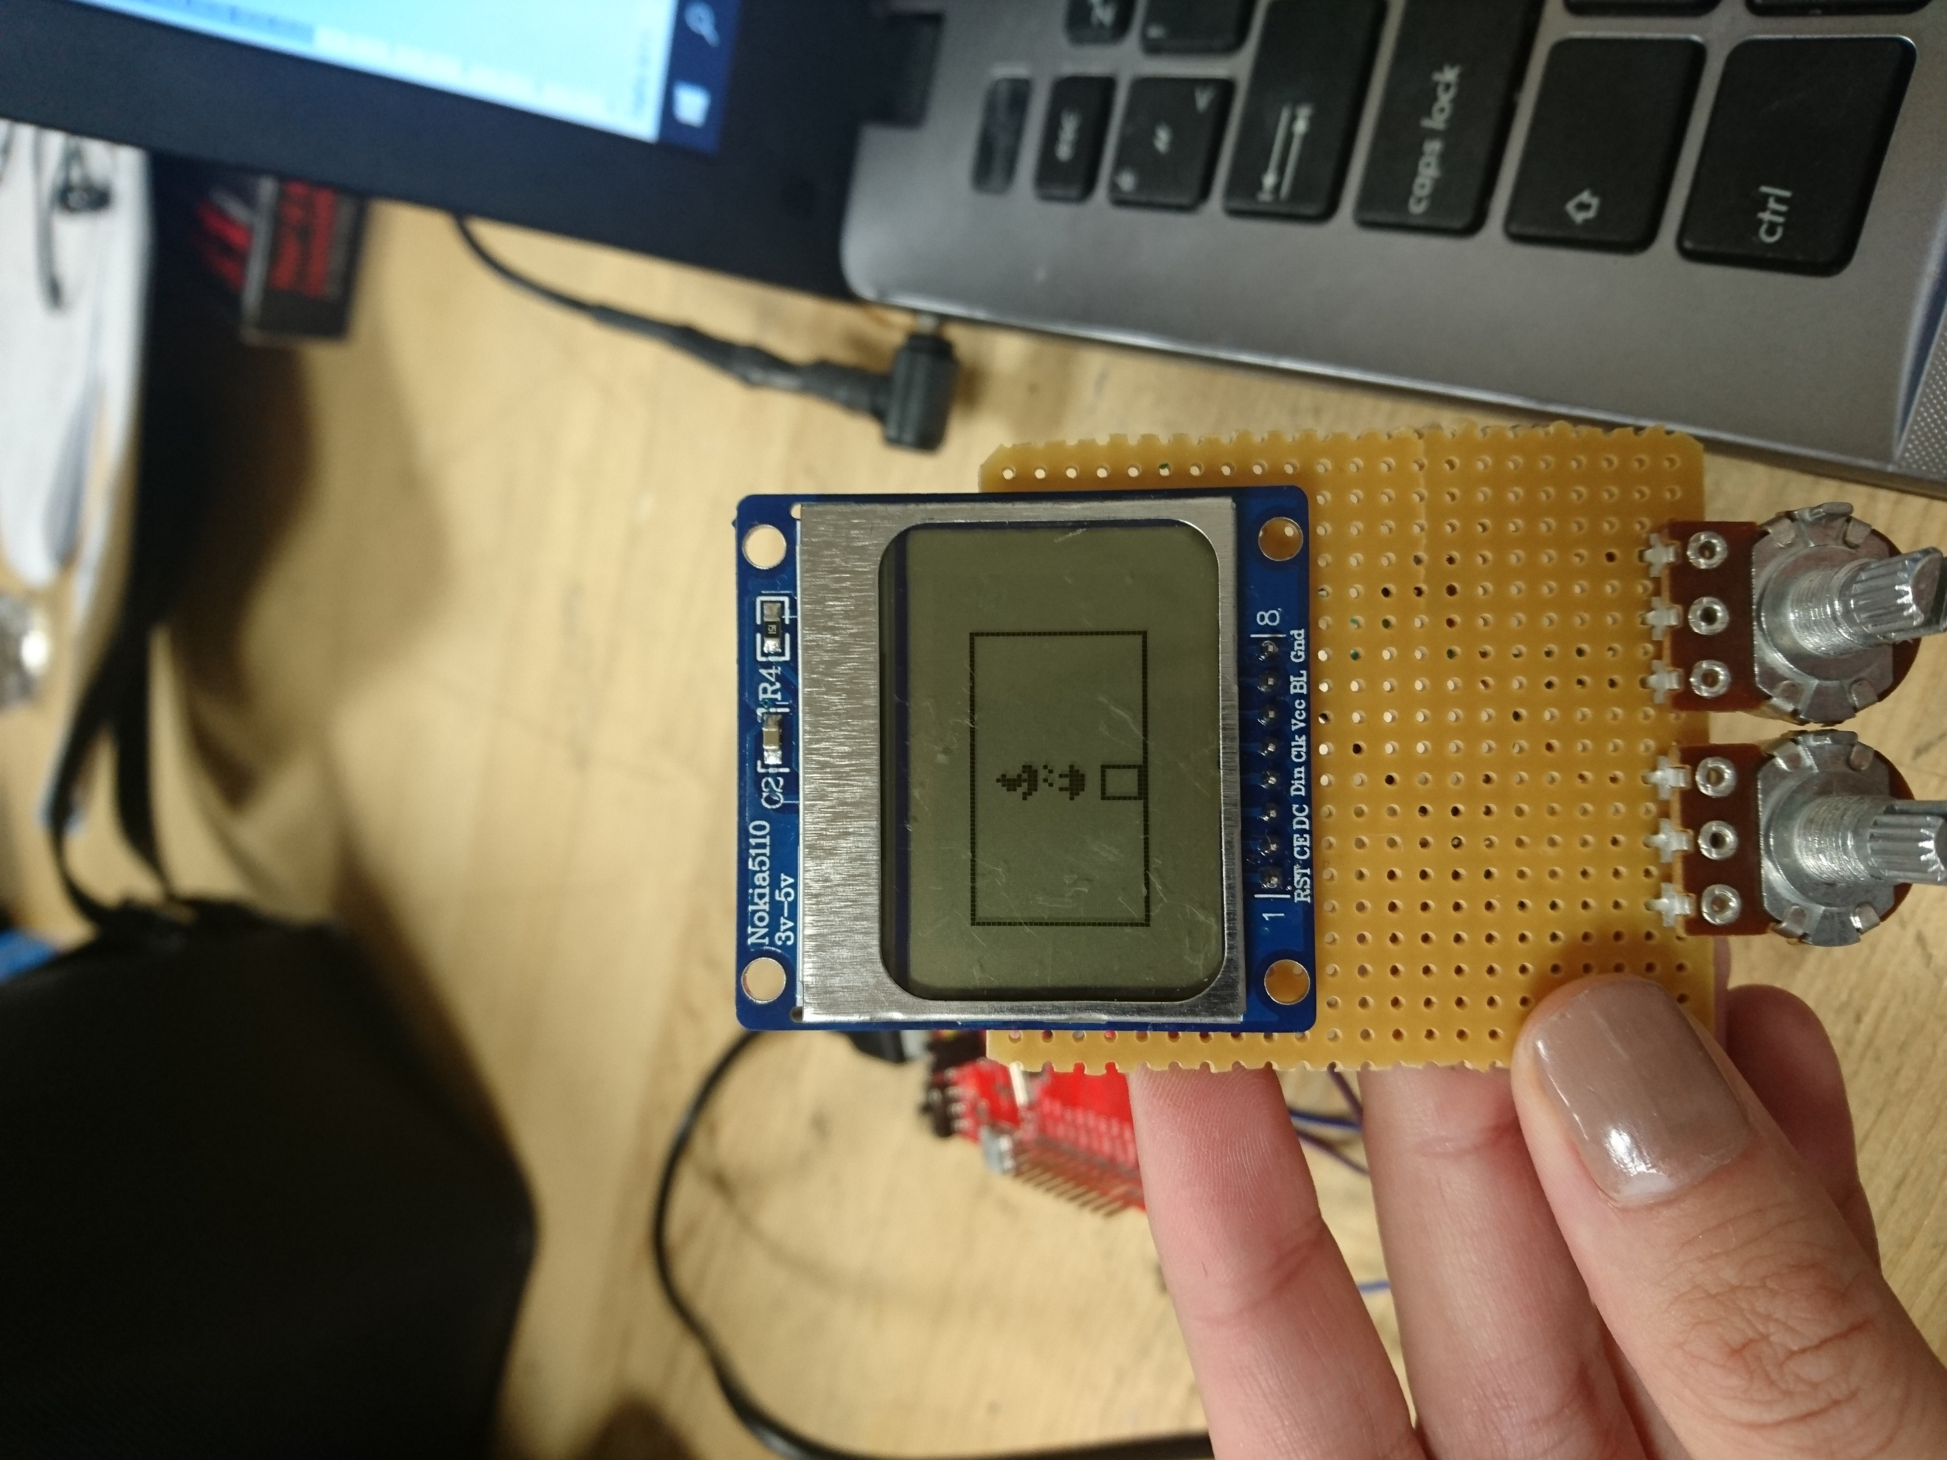

*Figure 6: On screen visualization of PLAYFIELD with civilian ship(top), battleship(middle) and ship cursor(bottom).*

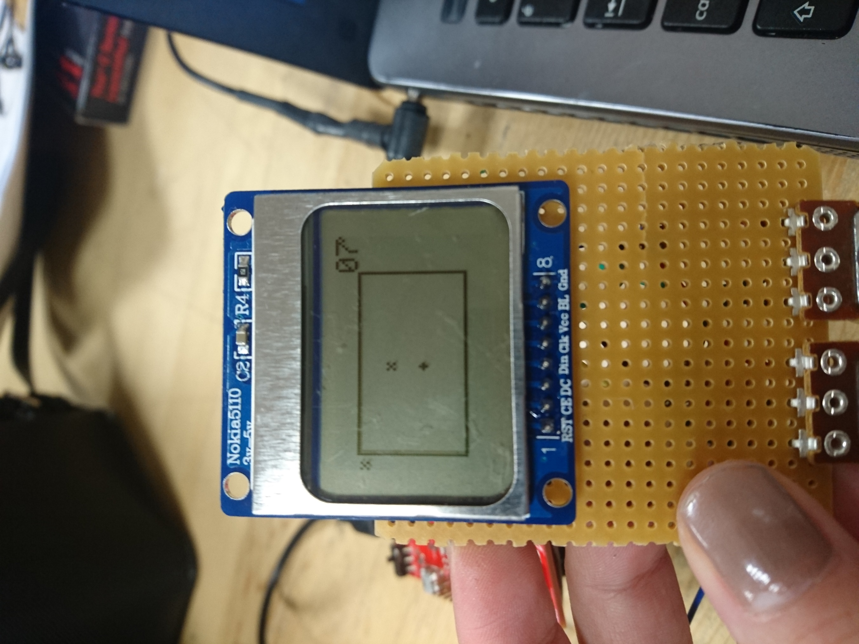

Figure 7: On screen visualization of MINEFIELD with mine(top) and mine cursor(bottom).

## CURSORS

In the visual design of this game console, cursor location subroutines hold very important role. Without proper operation of cursor, it is impossible for player to place any ship or mine. To fit with different needs of the game we have two different cursor subroutines, “SHIP_CURSOR” and “MINE_CURSOR”. Despite their different names and areas of uses, there is only minor differences. Hence in this part we will explain the operation of the “SHIP_CURSOR” subroutine and after that state the differences between “MINE_CURSOR”.

Cursor units take their input very similar to “ADDRESS_CHANGE” which shown in Figure 4. On the other hand, in this block we also have a ship type input which is located in most significant byte. If the type is 0x11 then it is cursor. For the input is 0x01, it means civilian ship and for 0x10 input it means battleship for us. The bitmap is shown in Figure 8.

|  |  |  |  |  |  |  |  |
| --- | --- | --- | --- | --- | --- | --- | --- |
| 31 | 24:23 | | 16:15 | | 8:7 | | 0 |
| MMMM.MMMM | | 0000.0000 | | YYYY.YYYY | | XXXX.XXXX | |

*Figure 8: Bitmap configuration of R4 data input*

The operation of cursor can be divided into three parts as “clear old cursor”, “change field memory” and “cursor write”. At the start of the operation the main aim is clearing the old cursor, so we will continue with clear glitch free screen. For that we benefit from the “OLD_SHIP_LOC” memory. The previous location of cursor is kept in this memory address, and we first need to clear this location. To clear it, we set the memory address of screen to old cursor location. Then we send playfield visual data which we keep at “PLAYFIELD” memory array.

After clearing the old cursor, we come to a decision point. If no button is pressed, it skips memory write part and directly moves to “cursor write” part. If ship input is present, then moves to “change field memory “part. In change memory part, the corresponding ship bitmap is written onto the “PLAYFIELD” location by ORR operation with old memory. This ORR with past values preserves the old writings. The ship shapes and cursor shape can be observed in Figure 6.

At the last stage we need to write cursor value on screen. But before starting we write the current cursor location to old cursor location memory. With this step we will be able to clear this cursor in the next step. After saving the cursor location we adjust the screen address to cursor location. Then we ORR the cursor bitmap with corresponding byte of “PLAYFIELD” memory and write onto the screen. As a result, old cursor location is changed with the new cursor location in this block.

To briefly state the main differences between “MINE_CURSOR” and “SHIP_CURSOR”, the ship bitmap is 8x8 bit. On the other hand, mine bitmaps are only 3x3 bit. This difference can be solved only by changing numerical values in the code. Also, in the mine mode there is only one place mine input which shown by both 0x01 and 0x10 inputs. The mine shape and cursor shape can be observed in Figure 6.

# Main System

## System Start

All of the modules in our code is connected to one big main system. Main system calls the codes by BL operation. So, in order to fully understand how our whole system works it is important to understand the main system. First thing our main system does is to create memory map. Memory map is the part we used for storing the ship, cursor, screen data etc. Since, it is impossible to store such data in registers, memory map initially clears some memory and also adds ship, cursor visuals to memory map. Memory mapping is important so that we eliminate the residual memory reading from previous operations.

Secondly, main code initializes the submodules required for Player 1’s game. SPI configuration, screen initialization, ADC initialization and push button initializations made one by one.

## Player 1’s Turn

After the system starts game starts with visualizing Player1’s Turn on the screen. Figure 9 below shows the start screen. Now it is time to start game with Player 1’s turn.

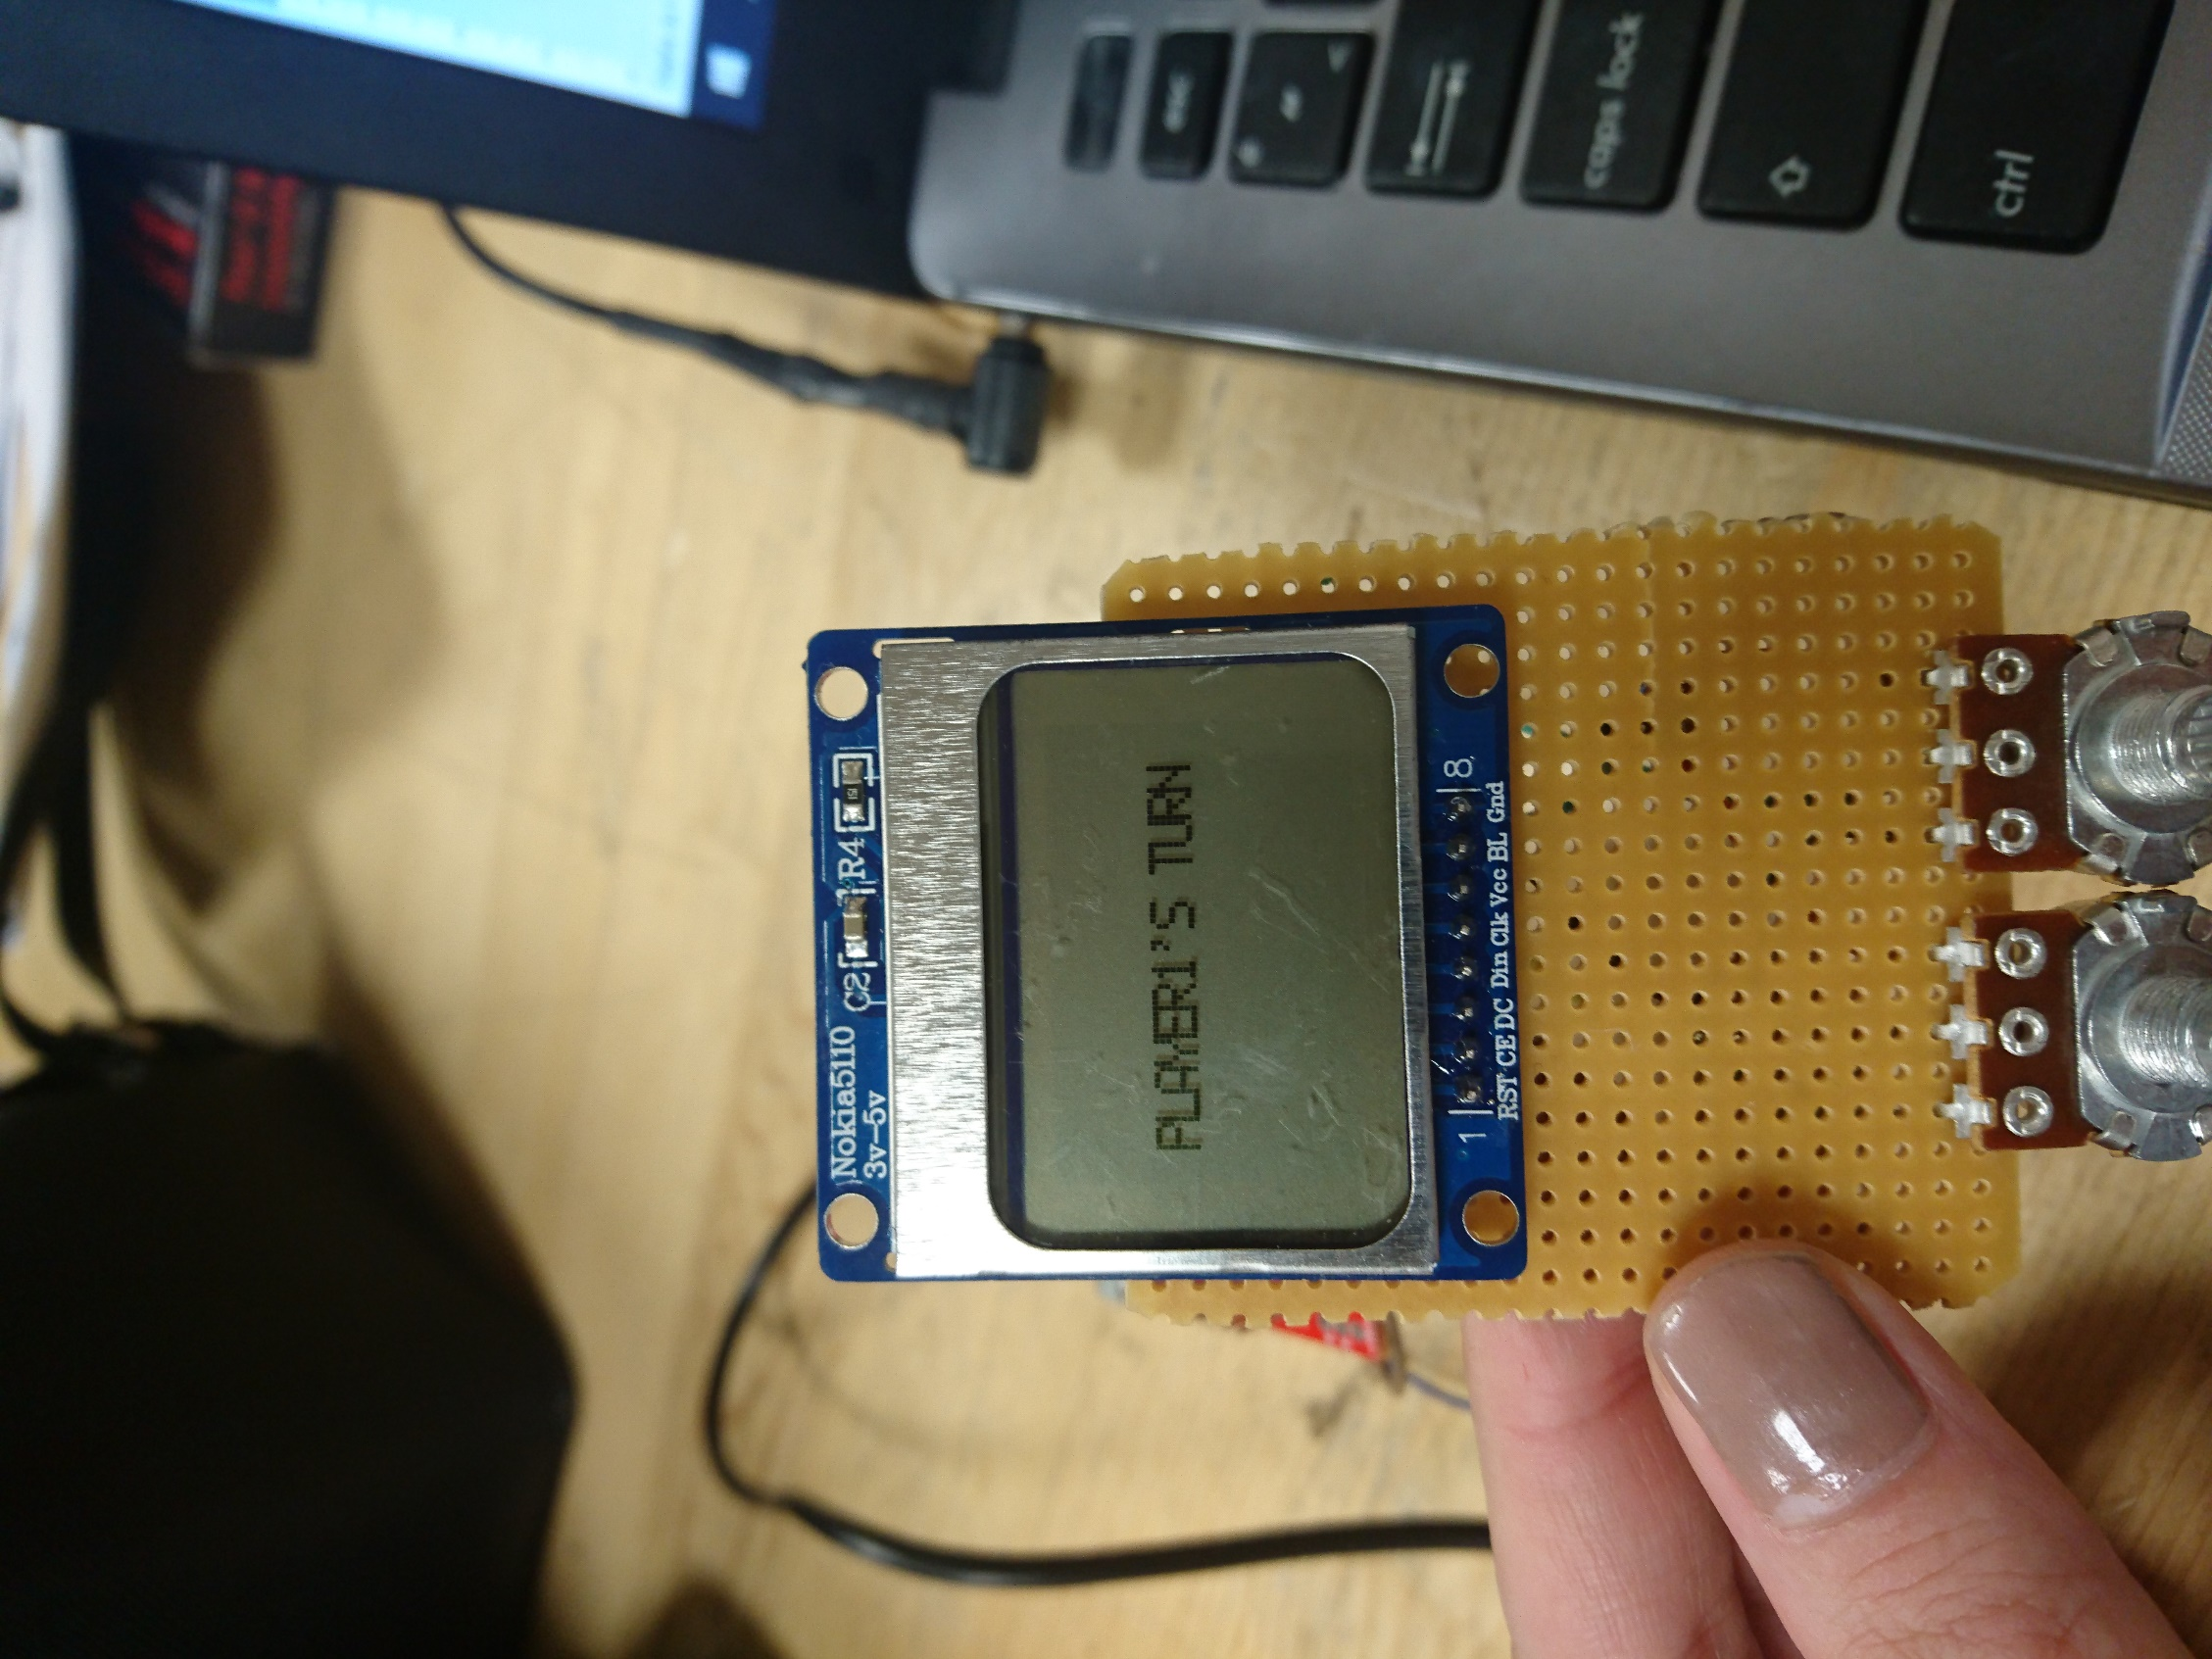

Figure 9: Start screen showing it is player 1's turn

A button should be pushed in order to skip this screen and start deploying ships. After that code goes to Player1 submodule which can be found in Appendix 6. First this code shows an empty field on the screen. Also, if a button pushed it deploys ships and record the address data in memory for the end of the game. Figure 10 below shows the screen for Player 1 when one civilian and one battleship deployed. The system below waits until there are 4 ships on screen.

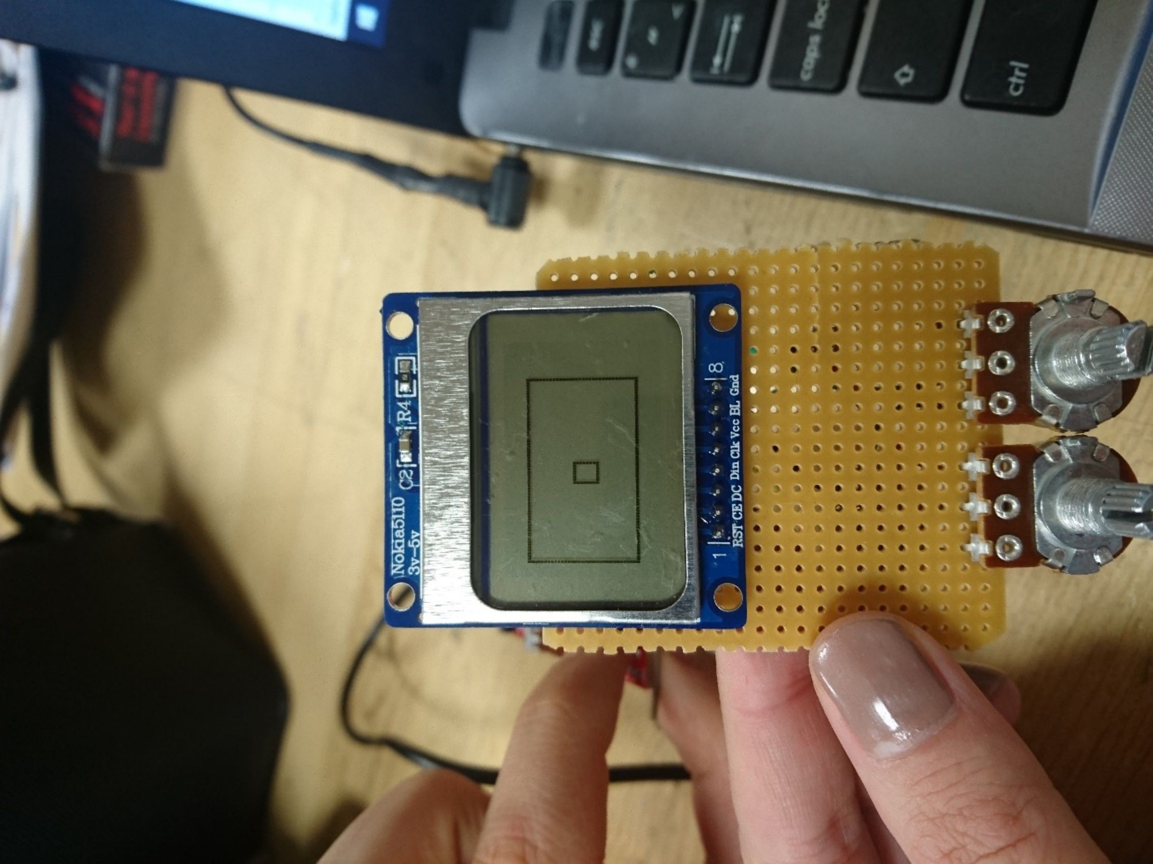

Figure 10: Empty field with ship cursor before any ships are deployed

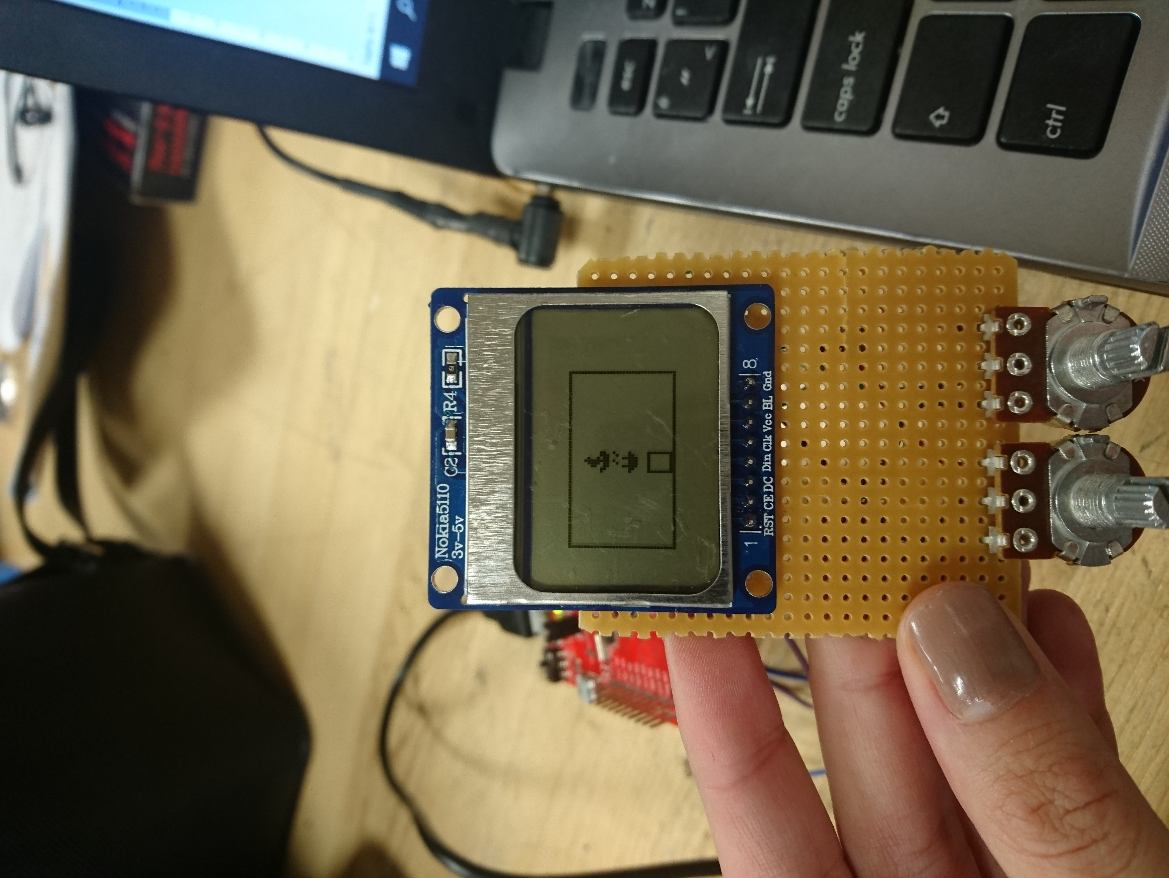

Figure 11: Player 1 game screen

After there are 4 ships on the screen system is still using the cursor but when the Player 1 pushes the button it means that Player 1 is happy with its selections. Memory map function used for visualizing the ships deployed on the screen all the time through operation. After the button pushed it means it is Player 2’s turn. It can be seen in Figure 11 below has two different ship figures representing civilian ships and battleships.

## Player 2’s Turn

When the button pressed by the Player 1 screen shows Player 2’s turns on the screen. Figure 12 below shows the start screen for Player 2.

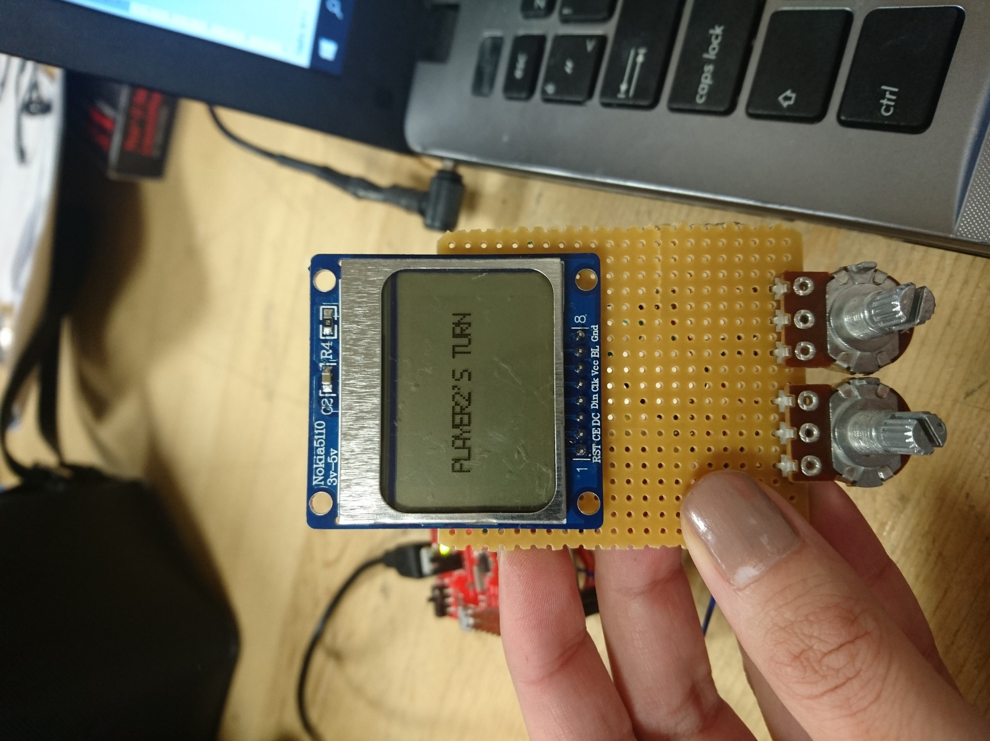

Figure 12: Screen visual for Player2's turn

When any pushed by Player 2 sneak peak of the ships will be visible for 0.5 second. With the end of 0.5 seconds game starts immediately by counting downwards from 20. Player 2 submodule starts with drawing an empty game field on the screen. Then branches and Links to SYSTICK­_INIT to initialize SysTick. With the initialization of SysTick counter starts to count downwards from 20 seconds. Figure 13 below shows the screen for Player2 which has a counter on the top right corner.

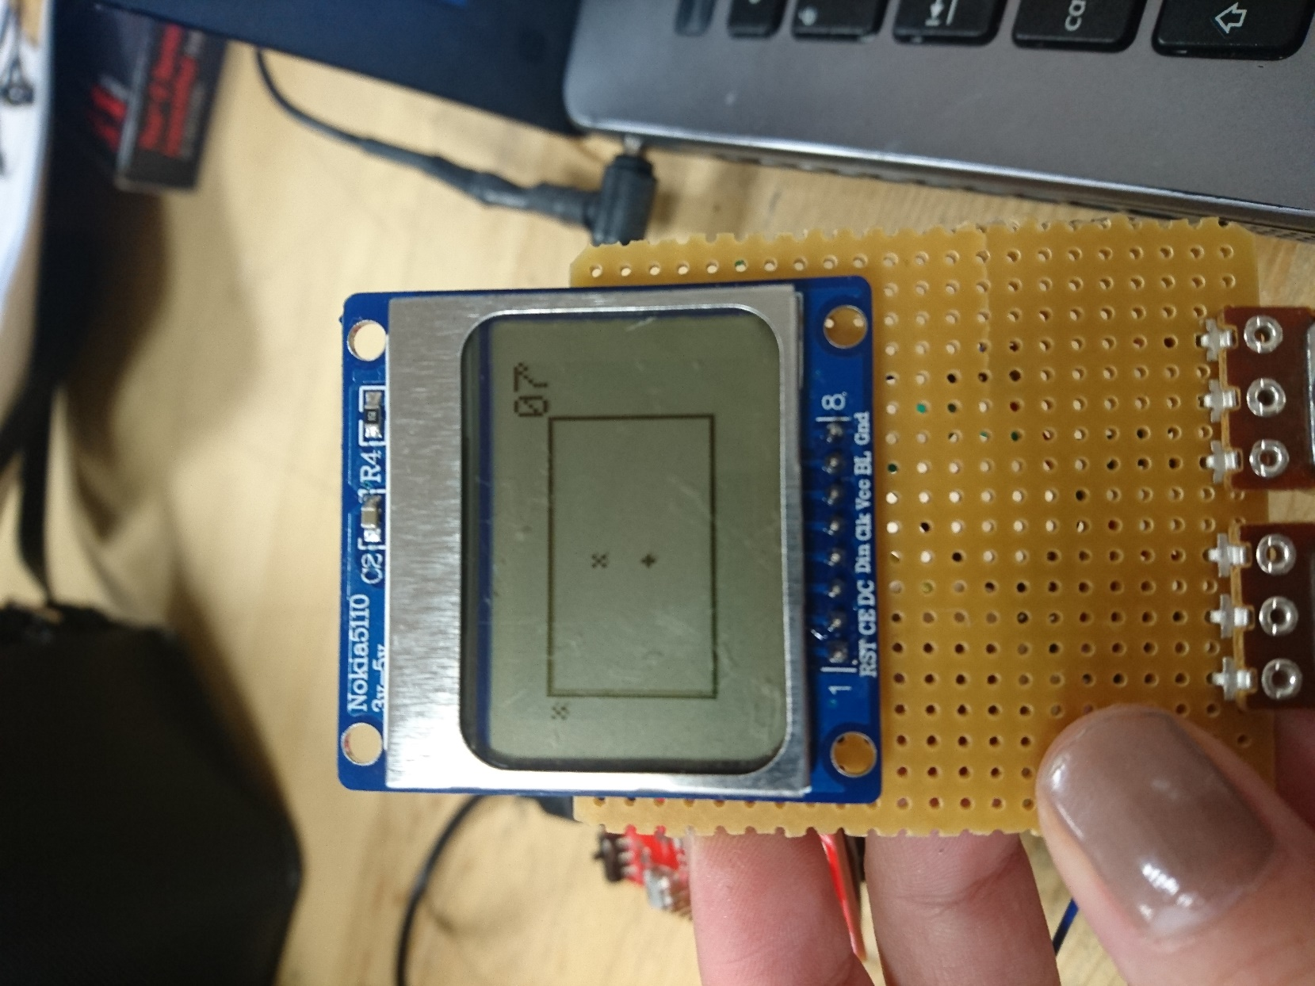

Figure 13: Screen for Player 2's turn

With the end of 20 seconds the system decides if Player 2 win or lose and shows the result on screen. Figure 14 below shows the screen for winning condition.

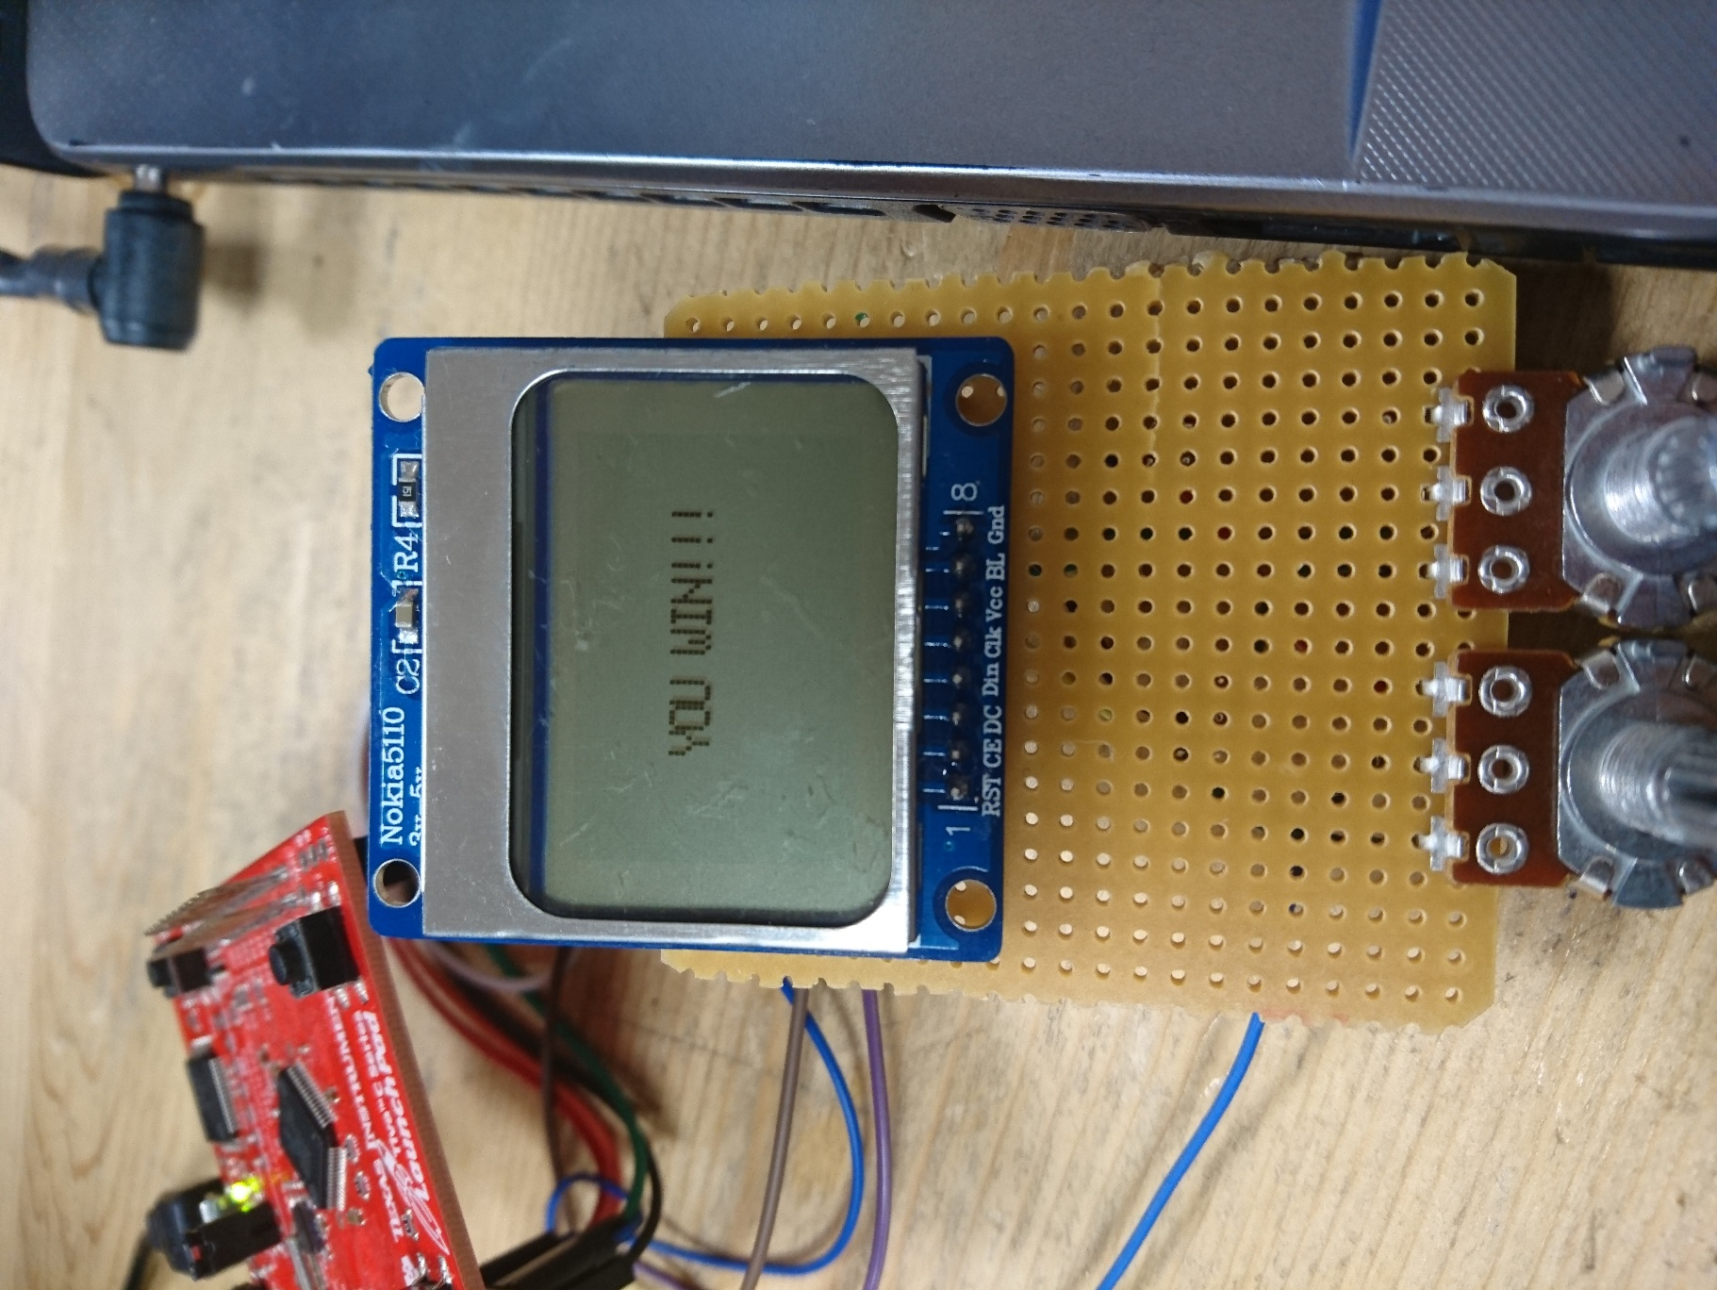

Figure 14: Result screen showing "You win!!!"

With the push of any button system returns the main and starts a new game.

# Equipment List

The following equipment are required to implement the battleship console project:

* NOKIA 5110 LCD Screen
* 2 Potentiometers
* TM4C123G Board

# Conclusion

In conclusion, this final report contains, game description, module definition and operations, final design and equipment needed for this project. Codes for this project can be found in Appendices. The codes are constructed using Assembly language. Assembly language is efficient for this operation because it gives us more contrsol over microprocessor submodules. SSI interface of TIVA board used for LED screen connection. ADC, SysTick, push button implementations made in this project. For these modules we used our previous knowledge on these topics. This project taught us to implement serial communication and utilize the facility on SPI protocol. It was important to understand functions of every component and their connections with different hardware and software for this project. At the end of this project we had a low-budget game console in our hand that we developed from scratch.

A hardware NOKIA 5110 LCD screen introduced to us with this project which made us familiar with SPI control as well as the hardware. This project was a brilliant way to combine all the information we gained during the experiments in the laboratory sessions with new ones.

# References

[1] Laboratory Project Manual: Battleship Game Console [Pdf]. (n.d.). METU Electrical and Electronics Engineering Department

[2] PCD8544 48 × 84 pixels matrix LCD controller/driver [Pdf]. (n.d.). Philips Semiconductors.

# Appendix 1

;***************************************************************

; EQU Directives

; These directives do not allocate memory

;***************************************************************

;SYMBOL DIRECTIVE VALUE COMMENT

; ADC Registers

RCGCADC EQU 0x400FE638 ; ADC clock register

; ADC0 base address EQU 0x40038000

ADC0_ACTSS EQU 0x40038000 ; Sample sequencer (ADC0 base address)

ADC0_RIS EQU 0x40038004 ; Interrupt status

ADC0_IM EQU 0x40038008 ; Interrupt select

ADC0_ISC EQU 0x40038034 ; Interrupt status and clear

ADC0_EMUX EQU 0x40038014 ; Trigger select

ADC0_PSSI EQU 0x40038028 ; Initiate sample

ADC0_SSMUX3 EQU 0x400380A0 ; Input channel select

ADC0_SSCTL3 EQU 0x400380A4 ; Sample sequence control

ADC0_SSFIFO3 EQU 0x400380A8 ; Channel 3 results

ADC0_PP EQU 0x40038FC4 ; Sample rate

ADC0_SAC EQU 0x40038030 ; Sample rate

; GPIO Registers

RCGCGPIO EQU 0x400FE608 ; GPIO clock register

; PORT E base address EQU 0x40024000

PORTE_DEN EQU 0x4002451C ; Digital Enable

PORTE_PCTL EQU 0x4002452C ; Alternative function configuration

PORTE_AFSEL EQU 0x40024420 ; Alternate function select

PORTE_AMSEL EQU 0x40024528 ; Enable analog

data EQU 0x20004000

***************************

;ADC1 FOR SAMPLING AIN1

***********************

ADC1_ACTSS EQU 0x40039000 ; Sample sequencer (ADC1 base address)

ADC1_RIS EQU 0x40039004 ; Interrupt status

ADC1_IM EQU 0x40039008 ; Interrupt select

ADC1_ISC EQU 0x40039034 ; Interrupt status and clear

ADC1_EMUX EQU 0x40039014 ; Trigger select

ADC1_PSSI EQU 0x40039028 ; Initiate sample

ADC1_SSMUX3 EQU 0x400390A0 ; Input channel select

ADC1_SSCTL3 EQU 0x400390A4 ; Sample sequence control

ADC1_SSFIFO3 EQU 0x400390A8 ; Channel 3 results

ADC1_PP EQU 0x40039FC4 ; Sample rate

ADC1_SAC EQU 0x40039030 ; Sample rate

; Start clocks for features to be used

;***************************************************************

; INITIALIZE ADC FOR AIN0 AND AIN1

; PE3 AND PE2 IS GOIN TO BE USED

;***************************************************************

;***************************************************************

; Program section

;***************************************************************

;LABEL DIRECTIVE VALUE COMMENT

AREA routines, READONLY, CODE

THUMB

EXPORT ADC_INIT

;***************************************************************

; ADC_INIT FUNCTION INITIALIZED ADC1 AND ADC0

;***************************************************************

;LABEL DIRECTIVE VALUE COMMENT

ADC_INIT PROC

PUSH {LR}

LDR R1, =RCGCADC ; Turn on ADC clock

LDR R0, [R1]

ORR R0, R0, #0x03 ; set bit 0 to enable ADC0 AND ADC1 clock

STR R0, [R1]

NOP

NOP

NOP ; Let clock stabilize

LDR R1, =RCGCGPIO ; Turn on GPIO clock

LDR R0, [R1]

ORR R0, R0, #0x10 ; set bit 4 to enable port E clock

STR R0, [R1]

NOP

NOP

NOP ; Let clock stabilize

; Setup GPIO to make PE3 input for ADC0

; Enable alternate functions

LDR R1, =PORTE_AFSEL

LDR R0, [R1]

ORR R0, R0, #0x06 ; set bit 3 to enable alt functions on PE3 AND SET BIT 2 TO ENABLE PE2

STR R0, [R1]

; PCTL does not have to be configured

; since ADC0 is automatically selected when

; port pin is set to analog.

; Disable digital on PE3

LDR R1, =PORTE_DEN

LDR R0, [R1]

BIC R0, R0, #0x06 ; clear bit 3 to disable analog on PE3 AND PE2

STR R0, [R1]

; Enable analog on PE3

LDR R1, =PORTE_AMSEL

LDR R0, [R1]

ORR R0, R0, #0x06 ; set bit 3 to enable analog on PE3

STR R0, [R1]

; Disable sequencer while ADC setup

;;;ENABLE ADC0 AND ADC PORTS

;;ADC SETUPS WILL BE DONE

LDR R1, =ADC0_ACTSS

LDR R0, [R1]

BIC R0, R0, #0x08 ; clear bit 3 to disable seq 3

STR R0, [R1]

; Select trigger source

LDR R1, =ADC0_EMUX

LDR R0, [R1]

BIC R0, R0, #0xF000 ; clear bits 15:12 to select SOFTWARE trigger

STR R0, [R1]

; Select input channel

LDR R1, =ADC0_SSMUX3

LDR R0, [R1]

;BIC R0, R0, #0x000F ; clear bits 3:0 to select AIN2

ORR R0, R0, #0x0002

BIC R0, R0, #0x000D

STR R0, [R1]

; Config sample sequence

LDR R1, =ADC0_SSCTL3

LDR R0, [R1]

ORR R0, R0, #0x06 ; set bit 1 (END0)

STR R0, [R1]

; Set sample rate

LDR R1, =ADC0_PP

LDR R0, [R1]

ORR R0, R0, #0x01 ; set bits 3:0 to 1 for 125k sps

STR R0, [R1]

; Done with setup, enable sequencer

LDR R1, =ADC0_SAC

LDR R0, [R1]

ORR R0, R0, #0x02

STR R0, [R1]

LDR R1, =ADC0_ACTSS

LDR R0, [R1]

ORR R0, R0, #0x08 ; set bit 3 to enable seq 3

STR R0, [R1] ; sampling enabled but not initiated yet

; ADC1 INITIALIZATION

LDR R1, =ADC1_ACTSS

LDR R0, [R1]

BIC R0, R0, #0x08 ; clear bit 3 to disable seq 3

STR R0, [R1]

; Select trigger source

LDR R1, =ADC1_EMUX

LDR R0, [R1]

BIC R0, R0, #0xF000 ; clear bits 15:12 to select SOFTWARE trigger

STR R0, [R1]

; Select input channel

LDR R1, =ADC1_SSMUX3

LDR R0, [R1]

ORR R0 , #0x1;

BIC R0, R0, #0x000E ; clear bits 3:0 to select AIN1 00001

STR R0, [R1]

; Config sample sequence

LDR R1, =ADC1_SSCTL3

LDR R0, [R1]

ORR R0, R0, #0x06 ; set bit 1 (END0)

STR R0, [R1]

; Set sample rate

LDR R1, =ADC1_PP

LDR R0, [R1]

ORR R0, R0, #0x01 ; set bits 3:0 to 1 for 125k sps

STR R0, [R1]

; Done with setup, enable sequencer

LDR R1, =ADC1_SAC

LDR R0, [R1]

ORR R0, R0, #0x02 ; set bit 3 to enable seq 3

STR R0, [R1] ; sampling enabled but not initiated yet

LDR R1, =ADC1_ACTSS

LDR R0, [R1]

ORR R0, R0, #0x08 ; set bit 3 to enable seq 3

STR R0, [R1] ; sampling enabled but not initiated yet

LDR R1, =ADC1_SAC

LDR R0, [R1]

ORR R0, R0, #0x02 ; set bit 3 to enable seq 3

STR R0, [R1] ; sampling enabled but not initiated yet

POP {LR}

BX LR

ENDP ;; END OF INITIALIZATION

;***************************************************************

; ADC_READ_SHIP FUNCTION READS THE AIN0 AND AIN1 DATA

; RETURNS YDATA XDATA IN R4 REGISTER

; COMPUTATION FOR SHIP PLACEMENT MADE IN THIS SUBMODULE

;***************************************************************

;LABEL DIRECTIVE VALUE COMMENT

EXPORT ADC_READ_SHIP

ADC_READ_SHIP PROC

PUSH {LR}

*******************************

; READ AIN0 FIRST

; PE3 CONTROLS X DATA

; VERTICAL MOVEMENT

; KEEPS DATA IN R5

*******************************

LDR R3, =ADC0_RIS ; interrupt address

LDR R4, =ADC0_SSFIFO3 ; result address

LDR R2, =ADC0_PSSI ; sample sequence initiate address

LDR R6,= ADC0_ISC ; interrupt status and clear

; initiate sampling by enabling sequencer 3 in ADC0_PSSI

Smpl0 LDR R0, [R2]

ORR R0, R0, #0x08 ; set bit 3 for SS3 in PSSI

STR R0, [R2]

; check for sample complete (bit 3 of ADC0_RIS set)

Cont0 LDR R0, [R3]

ANDS R0, R0, #8 ;RIS bit

BEQ Cont0

LDR R5,[R4] ; R5 KEEPS THE ADC0 READING

MOV R0, #8

LDR R6,= ADC0_ISC

STR R0, [R6] ; clear flag in ISC

*******************************

; READ AIN1

; PE2 CONTROLS Y DATA

; HORIZONTAL MOVEMENT

; KEEPS DATA IN R1

*******************************

ADC1_READ

LDR R3, =ADC1_RIS ; interrupt address

LDR R4, =ADC1_SSFIFO3 ; result address

LDR R2, =ADC1_PSSI ; sample sequence initiate address

LDR R6,= ADC1_ISC ; interrupt status and clear

Smpl1 LDR R0, [R2]

ORR R0, R0, #0x08 ; set bit 3 for SS3 in PSSI

STR R0, [R2]

; check for sample complete (bit 3 of ADC0_RIS set)

Cont1 LDR R0, [R3]

ANDS R0, R0, #8 ;RIS bit

BEQ Cont1

LDR R1,[R4] ; R1 KEEPS THE ADC1 READING

MOV R0, #8

LDR R6,= ADC1_ISC

STR R0, [R6] ; clear flag in ISC

****************

; R1 KEEPS AIN1 READING

; R5 KEEPS AIN0 READING

; XDATA AND YDATA TRANSFORMS TO THE PIXEL VALUE

; R4 KEEPS [YDATA, XDATA]

; LEAST SIGNIFICANT 4 BITS SHOWS X DATA

; BITS FROM 3-7 SHOWS YDATA

**********

COMPUTE

LDR R3, =73 ; R3 IS THE DIVISOR

UDIV R5, R5, R3 ;

ADD R5, #6 ; R5 KEEPS THE X

LDR R3, =170 ;

UDIV R1, R1, R3;

ADD R1, #8 ; ; R1 KEEPS THE Y DATA

LSL R1,R1,#8 ; SHIFT Y DATA

ADD R4, R1, R5 ; ADD XDATA YDATA

; R4 IS IN FROM [YDATA, XDATA]

POP{LR} ; END OF THE OPERATION

BX LR

ENDP ; RETURN R4

;***************************************************************

; ADC_READ_CURSOR FUNCTION READS THE AIN0 AND AIN1 DATA

; RETURNS YDATA XDATA IN R4 REGISTER

; COMPUTATION FOR CURSOR PLACEMENT MADE IN THIS SUBMODULE

;***************************************************************

;LABEL DIRECTIVE VALUE COMMENT

EXPORT ADC_READ_CURSOR

ADC_READ_CURSOR PROC

PUSH {LR}

LDR R3, =ADC0_RIS ; interrupt address

LDR R4, =ADC0_SSFIFO3 ; result address

LDR R2, =ADC0_PSSI ; sample sequence initiate address

LDR R6,= ADC0_ISC ; interrupt status and clear

; initiate sampling by enabling sequencer 3 in ADC0_PSSI

Smpl0_CURSOR LDR R0, [R2]

ORR R0, R0, #0x08 ; set bit 3 for SS3 in PSSI

STR R0, [R2]

; check for sample complete (bit 3 of ADC0_RIS set)

Cont0_CURSOR LDR R0, [R3]

ANDS R0, R0, #8 ;RIS bit

BEQ Cont0

LDR R5,[R4] ; R5 KEEPS THE ADC0 READING

MOV R0, #8

LDR R6,= ADC0_ISC

STR R0, [R6] ; clear flag in ISC

ADC1_READ_CURSOR

LDR R3, =ADC1_RIS ; interrupt address

LDR R4, =ADC1_SSFIFO3 ; result address

LDR R2, =ADC1_PSSI ; sample sequence initiate address

LDR R6,= ADC1_ISC ; interrupt status and clear

Smpl1_CURSOR LDR R0, [R2]

ORR R0, R0, #0x08 ; set bit 3 for SS3 in PSSI

STR R0, [R2]

; check for sample complete (bit 3 of ADC0_RIS set)

Cont1_CURSOR LDR R0, [R3]

ANDS R0, R0, #8 ;RIS bit

BEQ Cont1

LDR R1,[R4] ; R1 KEEPS THE ADC1 READING

MOV R0, #8

LDR R6,= ADC1_ISC

STR R0, [R6] ; clear flag in ISC

****************

; R1 KEEPS ADC1 READING

; R5 KEEPS ADC0 READING

**********

COMPUTE_CURSOR

LDR R3, =67 ; R3 IS THE DIVISOR

UDIV R5, R5, R3 ;

ADD R5, #7 ; R5 KEEPS THE X

LDR R3, =137 ;

UDIV R1, R1, R3;

ADD R1, #9 ; ; R1 KEEPS THE Y DATA

LSL R1,R1,#8 ; SHIFT Y DATA

ADD R4, R1, R5 ; ADD XDATA YDATA

; R4 IS IN FROM [YDATA, XDATA]

POP{LR} ; RETURN R4 DATA

BX LR

ENDP

ALIGN

END

# Appendix 2

;***************************************************************

; EQU Directives

; These directives do not allocate memory

;***************************************************************

;SYMBOL DIRECTIVE VALUE COMMENT

SYSCTL_RCGCGPIO EQU 0x400FE608 ;Enable GPIO

GPIO_PORTA_DIR EQU 0x40004400 ;Direction reg

GPIO_PORTA_AFSEL EQU 0x40004420 ;Alternate function

GPIO_PORTA_PCTL EQU 0x4000452C ;Port Control

GPIO_PORTA_DEN EQU 0x4000451C ;Digital enable

GPIO_PORTA_AMSEL EQU 0x40004528 ;Analog Enable

SYSCTL_RCGCSSI EQU 0x400FE61C ;Enable SSI

SSI0_CR0 EQU 0x40008000 ;SSI Control 0

SSI0_CR1 EQU 0x40008004 ;SSI Control 1

SSI0_CPSR EQU 0x40008010 ;Clock Prescale

SSI0_CC EQU 0x40008FC8 ;Clock Configuration

;***************************************************************

; Directives - This Data Section is part of the code

; It is in the read only section so values cannot be changed.

;***************************************************************

;LABEL DIRECTIVE VALUE COMMENT

AREA sdata, DATA, READONLY

THUMB

;***************************************************************

; Program section

;***************************************************************

;LABEL DIRECTIVE VALUE COMMENT

AREA routines,READONLY,CODE

THUMB

ALIGN

EXPORT SPI_CONFIG

;***************************************************************

; Main Function

; CE - PA3

; Din- PA5

; CLK- PA2

;***************************************************************

;LABEL DIRECTIVE VALUE COMMENT

SPI_CONFIG PROC

GPIO_INIT LDR R1,=SYSCTL_RCGCGPIO ; Initalize Clock

LDR R0,[R1]

ORR R0,R0,#0x01

STR R0,[R1]

NOP

NOP

NOP

NOP ; let GPIO clock stabilize

LDR R1,=GPIO_PORTA_DIR ;Set Direction of Pins

LDR R0,[R1]

ORR R0,R0,#0x2C ;PA2,PA3,PA5 are output

BIC R0,R0,#0x10 ;PA4 is input

STR R0,[R1]

LDR R1,=GPIO_PORTA_DEN ;Digitally enable ports

LDR R0,[R1]

ORR R0,R0,#0x3C

STR R0,[R1]

LDR R1,=GPIO_PORTA_AMSEL ;Disable analog Function

LDR R0,[R1]

BIC R0,R0,#0x3C

STR R0,[R1]

LDR R1,=GPIO_PORTA_AFSEL ;Enable Alternate Functions

LDR R0,[R1]

ORR R0,R0,#0x3C

STR R0,[R1]

LDR R1,=GPIO_PORTA_PCTL ;Route SSI interface to pins

LDR R0,[R1]

LDR R2,=0x222200

ORR R0,R0,R2

STR R0,[R1]

SPI_INIT LDR R1,=SYSCTL_RCGCSSI ; Initalize Clock

LDR R0,[R1]

ORR R0,R0,#0x01

STR R0,[R1]

NOP

NOP

NOP

NOP

NOP

LDR R1,=SSI0_CR1 ;Disable SSI interface

LDR R0,[R1]

BIC R0,R0,#0x00

STR R0,[R1]

LDR R1,=SSI0_CC ;Clock Configuration

LDR R0,[R1]

BIC R0,R0,#0x0F ;Choose SYSTEM CLK

STR R0,[R1]

LDR R1,=SSI0_CPSR ;Enable Clock Prescale

LDR R0,[R1]

ORR R0,R0,#0x02 ;80MHz to 40MHz

STR R0,[R1]

LDR R1,=SSI0_CR0 ;Control 0

LDR R0,[R1]

ORR R0,R0,#0x900 ;40MHz to 4MHz

ORR R0,R0,#0x07 ;8 bit Freescale mode

STR R0,[R1]

LDR R1,=SSI0_CR1 ;Enable SSI interface

LDR R0,[R1]

ORR R0,R0,#0x02

STR R0,[R1]

BX LR

;***************************************************************

; End of the program section

;***************************************************************

;LABEL DIRECTIVE VALUE COMMENT

ENDP

ALIGN

END

;***************************************************************

; EQU Directives

; These directives do not allocate memory

;***************************************************************

;SYMBOL DIRECTIVE VALUE COMMENT

SYSCTL_RCGCGPIO EQU 0x400FE608 ;Enable GPIO

GPIO_PORTB_DIR EQU 0x40005400 ;Direction reg

GPIO_PORTB_AFSEL EQU 0x40005420 ;Alternate function

GPIO_PORTB_DEN EQU 0x4000551C ;Digital enable

OUT_PORTB_RESET EQU 0x40005004 ;00000001

OUT_PORTB_DC EQU 0x40005008 ;00000010

SSI0_DR EQU 0x40008008

SSI0_SR EQU 0x4000800C

;***************************************************************

; Directives - This Data Section is part of the code

; It is in the read only section so values cannot be changed.

;***************************************************************

;LABEL DIRECTIVE VALUE COMMENT

AREA sdata, DATA, READONLY

THUMB

;***************************************************************

; Program section

;***************************************************************

;LABEL DIRECTIVE VALUE COMMENT

AREA routines,READONLY,CODE

THUMB

ALIGN

EXTERN DELAY_100ms

EXPORT SCREEN_INIT

;***************************************************************

; Main Function

; PB0 is RESET

; PB1 is D/C

;***************************************************************

;LABEL DIRECTIVE VALUE COMMENT

SCREEN_INIT PROC

PUSH {LR}

GPIO_INIT LDR R1,=SYSCTL_RCGCGPIO ; Initalize Clock

LDR R0,[R1]

ORR R0,R0,#0x02

STR R0,[R1]

NOP

NOP

NOP

NOP ;let GPIO clock stabilize

LDR R1,=GPIO_PORTB_DIR ;Set Direction of Pins

LDR R0,[R1]

ORR R0,R0,#0x03 ;PB0,PB1 are output

STR R0,[R1]

LDR R1,=GPIO_PORTB_DEN ;Digitally enable ports

LDR R0,[R1]

ORR R0,R0,#0x03

STR R0,[R1]

LDR R1,=GPIO_PORTB_AFSEL ;Disable Alternate Functions

LDR R0,[R1]

BIC R0,R0,#0x03

STR R0,[R1]

SCREEN LDR R1,= OUT_PORTB_RESET

MOV R0,#0xFF

STR R0,[R1]

BL DELAY_100ms

MOV R0,#0x00

STR R0,[R1]

BL DELAY_100ms

MOV R0,#0xFF

STR R0,[R1]

LDR R5,=OUT_PORTB_DC

MOV R1,#0x00

STR R1,[R5]

NOP

NOP

NOP

LDR R5,=SSI0_DR

MOV R1,#0x21

STR R1,[R5]

LDR R5,=SSI0_DR

MOV R1,#0xBF

STR R1,[R5]

LDR R5,=SSI0_DR

MOV R1,#0x05

STR R1,[R5]

LDR R5,=SSI0_DR

MOV R1,#0x13

STR R1,[R5]

LDR R5,=SSI0_DR

MOV R1,#0x20

STR R1,[R5]

LDR R5,=SSI0_DR

MOV R1,#0x0C

STR R1,[R5]

BL DELAY_100ms

POP {LR}

BX LR

;***************************************************************

; End of the program section

;***************************************************************

;LABEL DIRECTIVE VALUE COMMENT

ENDP

ALIGN

END

# Appendix3

;***************************************************************

; EQU Directives

; These directives do not allocate memory

;***************************************************************

;SYMBOL DIRECTIVE VALUE COMMENT

NVIC_ST_CTRL EQU 0xE000E010

NVIC_ST_RELOAD EQU 0xE000E014

NVIC_ST_CURRENT EQU 0xE000E018

;SHP_SYSPRI3 EQU 0xE000ED20

RELOAD_VALUE EQU 0x1499999 ;;; 1 saniye için degistir sonra

RELOAD_0 EQU 0x00000000

GPIO_PORTB_IN EQU 0x400053C0 ; B3 to B0

GPIO_PORTB_OUT EQU 0x4000503C ; B7 to B4

Field_Address EQU 0x20000400

OUT_PORTB_DC EQU 0x40005008 ;00000010

OUT_PORTB_RESET EQU 0x40005004 ;00000001

SSI0_DR EQU 0x40008008

SSI0_SR EQU 0x4000800C

;***************************************************************

; Program section

;***************************************************************

;LABEL DIRECTIVE VALUE COMMENT

AREA routines, CODE, READONLY, ALIGN=2

THUMB

EXPORT INIT_SYSTICK

EXTERN DATA_WRITE

EXTERN ADDRESS_CHANGE

EXTERN DELAY_1ms

;***************************************************************

; INITIALIZE SYSTICK

; THIS CODE SECTION INITIALIZE SYSTICK OPERATION FOR TIMER FROM 20-0

;***************************************************************

;LABEL DIRECTIVE VALUE COMMENT

INIT_SYSTICK PROC

PUSH {LR}

LDR R1,=NVIC_ST_CTRL

MOV R0,#0

STR R0,[R1]

LDR R1,=NVIC_ST_RELOAD

LDR R0,=RELOAD_VALUE

STR R0,[R1]

LDR R1,=NVIC_ST_CURRENT

STR R0,[R1]

LDR R1,=NVIC_ST_CTRL

MOV R0,#0x03

STR R0,[R1]

MOV R9,#21 ;

POP {LR}

BX LR

ENDP

;***************************************************************

; My_SYSTICK CODE WORKS FOR COUNTING DOWNWARD AND SHOW IT ON THE SCREEEN ACCORDINGLY

; To retain the past location of the cursor address we use R6

;***************************************************************

;LABEL DIRECTIVE VALUE COMMENT

EXTERN WINNER ; EXTERN THE SUBSYTEMS USED UN THIS MODULE

EXTERN LOSER

EXTERN WINORLOSE

EXTERN END_CASE

EXPORT My_SYSTICK

;***************************************************************

;LABEL DIRECTIVE VALUE COMMENT

My_SYSTICK PROC

PUSH {LR}

PUSH {R0- R6} ; PUSHES IMPORTANT VALUES

MOV R11, #1 ; FLAG FOR SECOND DIGIT

; INITIALIZE THE FLAG TO 1 IN ORDER TO WRITE 2 DIGITS EVERY OPERATION

CMP R9, #0 ; R9 keeps the value from 20 to 0

BNE cont ; if R9 is 0 clear the screen

LDR R1 , =NVIC_ST_CTRL ; AFTER 20 SECONDS DISABLE THE SYSTICK TIMER

MOV R0 , #0

STR R0 , [ R1 ]

MOV R9, #21 ; If R9 is 0 mov R9 =20 again and end the operation

POP {R0-R6}

POP {LR}

BL END_CASE ; BRANCH TO THE DECISON SUBMODULE FOR WINLOSE CONDUTION

B FINISH ; TO END THIS SUBMODULE AFTER THE END OF THE OPERATION

cont SUB R9,#1 ; substract R9

MOV R10,#10

UDIV R8,R9,R10 ; R8 keeps the first data which is either 0 1 2

MUL R0,R8,R10

SUB R0,R9,R0 ; R0 keeps the second value

LDR R4,=0x0047

BL ADDRESS_CHANGE ; GO TO TOP RIGHT CORNER

CMP R8, #2 ; FIND THE FIRST AND SECOND DIGIT BY COMPARING

BEQ write2

CMP R8,#1

BEQ write1

CMP R8, #0

BEQ write0

write0 MOV R4, #0x3e

BL DATA_WRITE

MOV R4,#0x51

BL DATA_WRITE

MOV R4, #0x49

BL DATA_WRITE

MOV R4, #0x45

BL DATA_WRITE

MOV R4, #0x3e

BL DATA_WRITE

B writebosluk

write1 MOV R4, #0x00

BL DATA_WRITE

MOV R4,#0x42

BL DATA_WRITE

MOV R4, #0x7F

BL DATA_WRITE

MOV R4, #0x40

BL DATA_WRITE

MOV R4, #0x00

BL DATA_WRITE

B writebosluk

write2 MOV R4, #0x42

BL DATA_WRITE

MOV R4,#0x61

BL DATA_WRITE

MOV R4, #0x51

BL DATA_WRITE

MOV R4, #0x49

BL DATA_WRITE

MOV R4, #0x46

BL DATA_WRITE

B writebosluk

write3 MOV R4, #0x21

BL DATA_WRITE

MOV R4,#0x41

BL DATA_WRITE

MOV R4, #0x45

BL DATA_WRITE

MOV R4, #0x4b

BL DATA_WRITE

MOV R4, #0x31

BL DATA_WRITE

B writebosluk

write4 MOV R4, #0x18

BL DATA_WRITE

MOV R4,#0x14

BL DATA_WRITE

MOV R4, #0x12

BL DATA_WRITE

MOV R4, #0x7f

BL DATA_WRITE

MOV R4, #0x10

BL DATA_WRITE

B writebosluk

write5 MOV R4, #0x27

BL DATA_WRITE

MOV R4,#0x45

BL DATA_WRITE

MOV R4, #0x45

BL DATA_WRITE

MOV R4, #0x45

BL DATA_WRITE

MOV R4, #0x39

BL DATA_WRITE

B writebosluk

write6 MOV R4, #0x3c

BL DATA_WRITE

MOV R4,#0x4a

BL DATA_WRITE

MOV R4, #0x49

BL DATA_WRITE

MOV R4, #0x49

BL DATA_WRITE

MOV R4, #0x30

BL DATA_WRITE

B writebosluk

write7 MOV R4, #0x01

BL DATA_WRITE

MOV R4,#0x71

BL DATA_WRITE

MOV R4, #0x09

BL DATA_WRITE

MOV R4, #0x05

BL DATA_WRITE

MOV R4, #0x03

BL DATA_WRITE

B writebosluk

write8 MOV R4, #0x36

BL DATA_WRITE

MOV R4,#0x49

BL DATA_WRITE

MOV R4, #0x49

BL DATA_WRITE

MOV R4, #0x49

BL DATA_WRITE

MOV R4, #0x36

BL DATA_WRITE

B writebosluk

write9 MOV R4, #0x06

BL DATA_WRITE

MOV R4,#0x49

BL DATA_WRITE

MOV R4, #0x49

BL DATA_WRITE

MOV R4, #0x29

BL DATA_WRITE

MOV R4, #0x1e

BL DATA_WRITE

B writebosluk

writebosluk

CMP R11, #0 ; CHECK THE FLAG TO KNOW IF THE SECOND DIGIT PRINTED

BEQ FINISH ; IF 2 DIGITS PRINTED END THE OPERATION

MOV R4, #0x00

BL DATA_WRITE

SUB R11, #1 ; ELSE PRINT THE SECOND DIGIT AND DECREASE THE FLAG

CMP R0, #0;

BEQ write0

CMP R0, #1;

BEQ write1

CMP R0, #2;

BEQ write2

CMP R0, #3;

BEQ write3

CMP R0, #4;

BEQ write4

CMP R0, #5;

BEQ write5

CMP R0, #6;

BEQ write6

CMP R0, #7;

BEQ write7

CMP R0, #8;

BEQ write8

CMP R0, #9;

BEQ write9

FINISH

POP {R0-R6}

POP {LR}

BX LR

ENDP

ALIGN

END

# Appendix 4

;***************************************************************

; EQU Directives

; These directives do not allocate memory

;***************************************************************

;SYMBOL DIRECTIVE VALUE COMMENT

EMPTY_FIELD EQU 0x20000400 ;400-5F7

PLAYFIELD EQU 0x20000600 ;600-7F7

MINEFIELD EQU 0x20002000 ;2000-21F

SHIP_EMPTY EQU 0x20000800 ;800-807

SHIP_CIVIL EQU 0x20000808 ;808-80F

SHIP_BATTLE EQU 0x20000810 ;810-817

FLAG_BATTLE EQU 0x20000810 ;for fun

FLAG_CARRIER EQU 0x20000808 ;for fun

CURSOR EQU 0x20000818 ;818-81A

MINE EQU 0x2000081B ;81B-81D

OLD_SHIP_LOC_X EQU 0x20001000 ;1000

OLD_SHIP_LOC_Y EQU 0x20001001 ;1001

OLD_CURSOR_LOC_X EQU 0x20001002 ;1002

OLD_CURSOR_LOC_Y EQU 0x20001003 ;1003

SHIP_MEMO EQU 0x20001100 ;1100-1149

MINE_MEMO EQU 0x20001150 ;1150-1199

GP_MEMORY EQU 0x20006000 ;6000-60FF Zero array for random use

;***************************************************************

; Directives - This Data Section is part of the code

; It is in the read only section so values cannot be changed.

;***************************************************************

;LABEL DIRECTIVE VALUE COMMENT

AREA sdata, DATA, READONLY

THUMB

;***************************************************************

; Program section

;***************************************************************

;LABEL DIRECTIVE VALUE COMMENT

AREA routines,READONLY,CODE

THUMB

ALIGN

EXTERN EMP_FIELD

EXPORT MEMORY_MAP

;***************************************************************

; Main Function

; Generates the pixel map of necessary objects in the memory

;***************************************************************

;LABEL DIRECTIVE VALUE COMMENT

MEMORY_MAP PROC

PUSH {LR}

LDR R5,=EMPTY_FIELD

BL EMP_FIELD

LDR R5,=PLAYFIELD

BL EMP_FIELD

LDR R5,=MINEFIELD

BL EMP_FIELD

;***************************************************************

empty_ship

LDR R5,=SHIP_EMPTY

MOV R0,#0xFF

STRB R0,[R5],#1

MOV R0,#0x81

STRB R0,[R5],#1

MOV R0,#0x81

STRB R0,[R5],#1

MOV R0,#0x81

STRB R0,[R5],#1

MOV R0,#0x81

STRB R0,[R5],#1

MOV R0,#0x81

STRB R0,[R5],#1

MOV R0,#0x81

STRB R0,[R5],#1

MOV R0,#0xFF

STRB R0,[R5],#1

;***************************************************************

Civilian_ship

LDR R5,=SHIP_CIVIL

MOV R0,#0xFF

STRB R0,[R5],#1

MOV R0,#0x81

STRB R0,[R5],#1

MOV R0,#0x99

STRB R0,[R5],#1

MOV R0,#0xA5

STRB R0,[R5],#1

MOV R0,#0xA5

STRB R0,[R5],#1

MOV R0,#0x81

STRB R0,[R5],#1

MOV R0,#0x81

STRB R0,[R5],#1

MOV R0,#0xFF

STRB R0,[R5],#1

;***************************************************************

Battleship

LDR R5,=SHIP_BATTLE

MOV R0,#0xFF

STRB R0,[R5],#1

MOV R0,#0xDB

STRB R0,[R5],#1

MOV R0,#0xA5

STRB R0,[R5],#1

MOV R0,#0xDB

STRB R0,[R5],#1

MOV R0,#0xDB

STRB R0,[R5],#1

MOV R0,#0xA5

STRB R0,[R5],#1

MOV R0,#0xDB

STRB R0,[R5],#1

MOV R0,#0xFF

STRB R0,[R5],#1

;***************************************************************

Cursor LDR R5,=CURSOR

MOV R0,#0x40

STRB R0,[R5],#1

MOV R0,#0xE0

STRB R0,[R5],#1

MOV R0,#0x40

STRB R0,[R5],#1

;***************************************************************

Mine LDR R5,=MINE

MOV R0,#0xA0

STRB R0,[R5],#1

MOV R0,#0x40

STRB R0,[R5],#1

MOV R0,#0xA0

STRB R0,[R5],#1

;***************************************************************

old_memo MOV R1,#0x10

LDR R5,=OLD_SHIP_LOC_X

MOV R0,#0x00

loop_oldm STRB R0,[R5],#1

SUBS R1,R1,#1

BNE loop_oldm

;***************************************************************

Clean_ship_and_cursor_memo

MOV R1,#0xFF

LDR R5,=SHIP_MEMO

MOV R0,#0x00

loop_sc STRB R0,[R5],#1

SUBS R1,R1,#1

BNE loop_sc

;***************************************************************

Ship_location_pointer

LDR R5,=SHIP_MEMO

ADD R1,R5,#4

STR R1,[R5]

;***************************************************************

Mine_location_pointer

LDR R5,=MINE_MEMO

ADD R1,R5,#4

STR R1,[R5]

;***************************************************************

flagship

LDR R5,=FLAG_BATTLE

MOV R0,#0x20

STRB R0,[R5],#1

MOV R0,#0x60

STRB R0,[R5],#1

MOV R0,#0xCC

STRB R0,[R5],#1

MOV R0,#0xDE

STRB R0,[R5],#1

MOV R0,#0xFF

STRB R0,[R5],#1

MOV R0,#0xD2

STRB R0,[R5],#1

MOV R0,#0xE0

STRB R0,[R5],#1

MOV R0,#0x60

STRB R0,[R5],#1

;***************************************************************

Carrier

LDR R5,=FLAG_CARRIER

MOV R0,#0x20

STRB R0,[R5],#1

MOV R0,#0x60

STRB R0,[R5],#1

MOV R0,#0xF8

STRB R0,[R5],#1

MOV R0,#0xE2

STRB R0,[R5],#1

MOV R0,#0xE1

STRB R0,[R5],#1

MOV R0,#0xF8

STRB R0,[R5],#1

MOV R0,#0x62

STRB R0,[R5],#1

MOV R0,#0x21

STRB R0,[R5],#1

;***************************************************************

GP_mem LDR R5,=GP_MEMORY

MOV R1,#0xFF

MOV R0,#0x00

loop_gpm STRB R0,[R5],#1

SUBS R1,R1,#1

BNE loop_gpm

;***************************************************************

POP {LR}

BX LR

;***************************************************************

; End of the program section

;***************************************************************

;LABEL DIRECTIVE VALUE COMMENT

ENDP

ALIGN

END

# Appendix 5

;***************************************************************

; EQU Directives

; These directives do not allocate memory

;***************************************************************

;SYMBOL DIRECTIVE VALUE COMMENT

OUT_PORTB_DC EQU 0x40005008 ;00000010

OLD_SHIP_LOC_X EQU 0x20001000 ;1000

OLD_SHIP_LOC_Y EQU 0x20001001 ;1001

PLAYFIELD EQU 0x20000600 ;600-7F7

SHIP_EMPTY EQU 0x20000800 ;800-807

SHIP_CIVIL EQU 0x20000808 ;808-80F

SHIP_BATTLE EQU 0x20000810 ;810-817

;***************************************************************

; Directives - This Data Section is part of the code

; It is in the read only section so values cannot be changed.

;***************************************************************

;LABEL DIRECTIVE VALUE COMMENT

AREA sdata, DATA, READONLY

THUMB

;***************************************************************

; Program section

;***************************************************************

;LABEL DIRECTIVE VALUE COMMENT

AREA routines,READONLY,CODE

THUMB

ALIGN

EXTERN DELAY_1ms

EXTERN DELAY_10ms

EXTERN ADDRESS_CHANGE

EXTERN DATA_WRITE

EXPORT SHIP_CURSOR

;***************************************************************

; Main Function

; Takes Op mode, y location and x location

; Data format M =

; 0000.00MM.0000.0000.YYYY.YYYY.XXXX.XXXX

;***************************************************************

;LABEL DIRECTIVE VALUE COMMENT

SHIP_CURSOR PROC

PUSH {LR}

PUSH {R0-R4}

LDR R5,=OLD_SHIP_LOC_Y

LDRB R0,[R5]

LSL R0,R0,#8

LDR R5,=OLD_SHIP_LOC_X

LDRB R1,[R5]

ADD R0,R0,R1

LDR R2,=0xFFFF

AND R1,R4,R2 ;Compare new location with old one

PUSH {R4} ;Save R4

CMP R1,R0

BEQ Skip_clear ;if they are same skip clear phase

;***************************************************************

;clear screen stage

;***************************************************************

Clear

LDR R5,=OLD_SHIP_LOC_Y

LDRB R0,[R5]

LSR R0,R0,#3 ;Extract the fractional part

LSL R4,R0,#8

LDR R5,=OLD_SHIP_LOC_X

LDRB R1,[R5]

ADD R4,R4,R1 ;create Yloc-Xloc structure for address change

BL DELAY_10ms

BL ADDRESS_CHANGE

MOV R3,#0x54

MUL R2,R0,R3 ;multiply Y coordinate with 84

ADD R2,R2,R1 ;find vertical mode address of pixel

LDR R5,=PLAYFIELD

ADD R5,R5,R2 ;find corresponding address of R5

MOV R3,#8 ;write 8 byte of data

playfield LDRB R4,[R5],#1

BL DATA_WRITE

SUBS R3,R3,#1

BNE playfield

LDR R3,=OLD_SHIP_LOC_Y

LDRB R0,[R3]

ANDS R1,R0,#0x07 ;control fractional part

BEQ Skip_clear

LDR R3,=OLD_SHIP_LOC_Y

LDRB R0,[R3]

LSR R0,R0,#3 ;Extract the fractional part

LSL R4,R0,#8

LDR R3,=OLD_SHIP_LOC_X

LDRB R1,[R3]

ADD R4,R4,R1 ;create Yloc-Xloc structure for address change

ADD R4,R4,#0x100 ;jump to next line

BL ADDRESS_CHANGE

ADD R5,R5,#0x4C

MOV R3,#8

playfield2 LDRB R4,[R5],#1

BL DATA_WRITE

SUBS R3,R3,#1

BNE playfield2

;***************************************************************

; case determine stage

;***************************************************************

Skip_clear POP {R4}

LSR R3,R4,#0x18 ;extact operation from coordinates

LDR R5,=OLD_SHIP_LOC_X

AND R0,R4,#0xFF

STRB R0,[R5]

LDR R5,=OLD_SHIP_LOC_Y

AND R0,R4,#0xFF00

LSR R0,R0,#8

STRB R0,[R5]

CMP R3,#0x01

BEQ civilian

CMP R3,#0x10

BEQ battleship

B on_screen

;***************************************************************

;Civilian ship stage

;***************************************************************

civilian LDR R5,=OLD_SHIP_LOC_X ;extract X coordinate

LDRB R0,[R5]

LDR R5,=OLD_SHIP_LOC_Y ;extract Y coordinate

LDRB R1,[R5]

AND R2,R1,#0x07 ;extract fractional Y coordinate

LSR R1,R1,#0x03 ;extract whole part

MOV R3,#0x54

MUL R3,R1,R3 ;multiply Y coordinate with 84

ADD R3,R3,R0 ;find vertical mode address of pixel

LDR R5,=PLAYFIELD ;take playfield address for writing op

ADD R5,R5,R3 ;adjust to ship location

LDR R6,=SHIP_CIVIL ;take civilian ship pattern

MOV R3,#8

civ_memo LDRB R0,[R5]

LDRB R1,[R6],#1

LSL R1,R1,R2 ;shift with fractional part to adjust ship

AND R1,R1,#0xFF

ORR R1,R1,R0 ;combine field data with ship data

STRB R1,[R5],#1 ;write into the memory

SUBS R3,R3,#1

BNE civ_memo

CMP R2,#0x00 ;if data is divided repeat same step for

BEQ on_screen ;lower byte frames

MOV R3,#8

ADD R5,R5,#0x4C

SUB R6,R6,#0x08

civ_memo2 LDRB R1,[R6],#1

LSL R1,R1,R2

LSR R1,R1,#8

LDRB R0,[R5]

ORR R1,R1,R0

STRB R1,[R5],#1

SUBS R3,R3,#1

BNE civ_memo2

B on_screen

;***************************************************************

;Battleship stage

;***************************************************************

battleship LDR R5,=OLD_SHIP_LOC_X ;extract X coordinate

LDRB R0,[R5]

LDR R5,=OLD_SHIP_LOC_Y ;extract Y coordinate

LDRB R1,[R5]

AND R2,R1,#0x07 ;extract fractional Y coordinate

LSR R1,R1,#0x03 ;extract whole part

MOV R3,#0x54

MUL R3,R1,R3 ;multiply Y coordinate with 84

ADD R3,R3,R0 ;find vertical mode address of pixel

LDR R5,=PLAYFIELD ;take playfield address for writing op

ADD R5,R5,R3 ;adjust to ship location

LDR R6,=SHIP_BATTLE ;take battle ship pattern

MOV R3,#8

bat_memo LDRB R0,[R5]

LDRB R1,[R6],#1

LSL R1,R1,R2 ;shift with fractional part to adjust ship

AND R1,R1,#0xFF

ORR R1,R1,R0 ;combine field data with ship data

STRB R1,[R5],#1 ;write into the memory

SUBS R3,R3,#1

BNE bat_memo

CMP R2,#0x00 ;if data is divided repeat same step for

BEQ on_screen ;lower byte frames

MOV R3,#8

ADD R5,R5,#0x4C

SUB R6,R6,#0x08

bat_memo2 LDRB R1,[R6],#1

LSL R1,R1,R2

LSR R1,R1,#8

LDRB R0,[R5]

ORR R1,R1,R0

STRB R1,[R5],#1

SUBS R3,R3,#1

BNE bat_memo2

B on_screen

;***************************************************************

;write screen stage

;***************************************************************

on_screen LDR R5,=OLD_SHIP_LOC_X ;extract X coordinate

LDRB R0,[R5]

LDR R5,=OLD_SHIP_LOC_Y ;extract Y coordinate

LDRB R1,[R5]

AND R2,R1,#0x07 ;extract fractional Y coordinate

LSR R1,R1,#0x03 ;extract whole part

LSL R4,R1,#8

ADD R4,R4,R0

BL ADDRESS_CHANGE

MOV R3,#0x54

MUL R3,R1,R3 ;multiply Y coordinate with 84

ADD R3,R3,R0 ;find vertical mode address of pixel

LDR R5,=PLAYFIELD ;take playfield address for writing op

ADD R5,R5,R3 ;adjust to ship location

LDR R6,=SHIP_EMPTY ;take empty ship pattern

MOV R3,#8

first_line LDRB R0,[R5],#1

LDRB R1,[R6],#1

LSL R1,R1,R2 ;shift with fractional part to adjust ship

AND R1,R1,#0xFF

ORR R4,R1,R0 ;combine field data with ship data

BL DATA_WRITE ;write to screen

SUBS R3,R3,#1

BNE first_line

CMP R2,#0x00 ;if data is divided repeat same step for

BEQ endline ;lower byte frames

MOV R3,#8

LDR R3,=OLD_SHIP_LOC_X ;extract X coordinate from newly written memory

LDRB R0,[R3]

LDR R3,=OLD_SHIP_LOC_Y ;extract Y coordinate from newly written memory

LDRB R1,[R3]

LSR R1,R1,#0x03 ;extract whole part

ADD R1,R1,#0x01 ;increment Y location

LSL R1,R1,#0x08

ADD R4,R1,R0

BL ADDRESS_CHANGE

MOV R3,#8

LDR R6,=SHIP_EMPTY ;take empty ship pattern

ADD R5,R5,#0x4C

second_line LDRB R1,[R6],#1

LSL R1,R1,R2 ;shift with fractional part to adjust ship

LSR R1,R1,#8

LDRB R0,[R5]

ORR R4,R1,R0 ;combine field data with ship data

BL DATA_WRITE ;write to screen

SUBS R3,R3,#1

BNE second_line

endline

POP {R0-R4}

POP {LR}

BX LR

;***************************************************************

; End of the program section

;***************************************************************

;LABEL DIRECTIVE VALUE COMMENT

ENDP

ALIGN

END

;***************************************************************

; EQU Directives

; These directives do not allocate memory

;***************************************************************

;SYMBOL DIRECTIVE VALUE COMMENT

OUT_PORTB_DC EQU 0x40005008 ;00000010

OLD_CURSOR_LOC_X EQU 0x20001000 ;1000

OLD_CURSOR_LOC_Y EQU 0x20001001 ;1001

MINEFIELD EQU 0x20002000 ;2000-21F

CURSOR EQU 0x20000818 ;818-81A

MINE EQU 0x2000081B ;81B-81D

;***************************************************************

; Directives - This Data Section is part of the code

; It is in the read only section so values cannot be changed.

;***************************************************************

;LABEL DIRECTIVE VALUE COMMENT

AREA sdata, DATA, READONLY

THUMB

;***************************************************************

; Program section

;***************************************************************

;LABEL DIRECTIVE VALUE COMMENT

AREA routines,READONLY,CODE

THUMB

ALIGN

EXTERN DELAY_1ms

EXTERN ADDRESS_CHANGE

EXTERN DATA_WRITE

EXPORT MINE_CURSOR

;***************************************************************

; Main Function

; Takes Op mode, y location and x location

; Data format M =

; 0000.00MM.0000.0000.YYYY.YYYY.XXXX.XXXX

;***************************************************************

;LABEL DIRECTIVE VALUE COMMENT

MINE_CURSOR PROC

PUSH {LR}

PUSH {R0-R4}

LDR R5,=0x0601

SUB R4,R4,R5

LDR R5,=OLD_CURSOR_LOC_Y

LDRB R0,[R5]

LSL R0,R0,#8

LDR R5,=OLD_CURSOR_LOC_X

LDRB R1,[R5]

ADD R0,R0,R1

LDR R2,=0xFFFF

AND R1,R4,R2 ;Compare new location with old one

PUSH {R4} ;Save R4

CMP R1,R0

BEQ Skip_clear ;if they are same skip clear phase

;***************************************************************

;clear screen stage

;***************************************************************

Clear

LDR R5,=OLD_CURSOR_LOC_Y

LDRB R0,[R5]

LSR R0,R0,#3 ;Extract the fractional part

LSL R4,R0,#8

LDR R5,=OLD_CURSOR_LOC_X

LDRB R1,[R5]

ADD R4,R4,R1 ;create Yloc-Xloc structure for address change

MOV R7,R4 ;preserve last written address in R7

BL ADDRESS_CHANGE

MOV R3,#0x54

MUL R2,R0,R3 ;multiply Y coordinate with 84

ADD R2,R2,R1 ;find vertical mode address of pixel

LDR R5,=MINEFIELD

ADD R5,R5,R2 ;find corresponding address of R5

MOV R3,#3 ;write 3 byte of data

minefield LDRB R4,[R5],#1

BL DATA_WRITE

ADD R7,R7,#1

SUBS R3,R3,#1

BNE minefield

LDR R3,=OLD_CURSOR_LOC_Y

LDRB R0,[R3]

ANDS R1,R0,#0x07 ;control fractional part

BEQ Skip_clear

LDR R3,=OLD_CURSOR_LOC_Y

LDRB R0,[R3]

LSR R0,R0,#3 ;Extract the fractional part

LSL R4,R0,#8

LDR R3,=OLD_CURSOR_LOC_X

LDRB R1,[R3]

ADD R4,R4,R1 ;create Yloc-Xloc structure for address change

ADD R4,R4,#0x100 ;jump to next line

MOV R7,R4

BL ADDRESS_CHANGE

ADD R5,R5,#0x51

MOV R3,#3

minefield2 LDRB R4,[R5],#1

BL DATA_WRITE

ADD R7,R7,#1

SUBS R3,R3,#1

BNE minefield2

;***************************************************************

; case determine stage

;***************************************************************

Skip_clear POP {R4}

LSR R3,R4,#0x18 ;extact operation from coordinates

LDR R5,=OLD_CURSOR_LOC_X

AND R0,R4,#0xFF

STRB R0,[R5]

LDR R5,=OLD_CURSOR_LOC_Y

AND R0,R4,#0xFF00

LSR R0,R0,#8

STRB R0,[R5]

CMP R3,#0x01

BEQ mine

CMP R3,#0x10

BEQ mine

B on_screen

;***************************************************************

;mine placement stage

;***************************************************************

mine LDR R5,=OLD_CURSOR_LOC_X ;extract X coordinate

LDRB R0,[R5]

LDR R5,=OLD_CURSOR_LOC_Y ;extract Y coordinate

LDRB R1,[R5]

AND R2,R1,#0x07 ;extract fractional Y coordinate

LSR R1,R1,#0x03 ;extract whole part

MOV R3,#0x54

MUL R3,R1,R3 ;multiply Y coordinate with 84

ADD R3,R3,R0 ;find vertical mode address of pixel

LDR R5,=MINEFIELD ;take minefield address for writing op

ADD R5,R5,R3 ;adjust to mine location

LDR R6,=MINE ;take mine pattern

MOV R3,#3

mine_memo LDRB R0,[R5]

LDRB R1,[R6],#1

LSL R1,R1,R2 ;shift with fractional part to adjust mine

AND R1,R1,#0xFF

ORR R1,R1,R0 ;combine field data with mine data

STRB R1,[R5],#1 ;write into the memory

SUBS R3,R3,#1

BNE mine_memo

CMP R2,#0x00 ;if data is divided repeat same step for

BEQ on_screen ;lower byte frames

MOV R3,#3

ADD R5,R5,#0x51

SUB R6,R6,#0x03

mine_memo2 LDRB R1,[R6],#1

LSL R1,R1,R2

LSR R1,R1,#8

LDRB R0,[R5]

ORR R1,R1,R0

STRB R1,[R5],#1

SUBS R3,R3,#1

BNE mine_memo2

B on_screen

;***************************************************************

;write screen stage

;***************************************************************

on_screen LDR R5,=OLD_CURSOR_LOC_X ;extract X coordinate

LDRB R0,[R5]

LDR R5,=OLD_CURSOR_LOC_Y ;extract Y coordinate

LDRB R1,[R5]

AND R2,R1,#0x07 ;extract fractional Y coordinate

LSR R1,R1,#0x03 ;extract whole part

LSL R4,R1,#8

ADD R4,R4,R0

MOV R7,R4

BL ADDRESS_CHANGE

MOV R3,#0x54

MUL R3,R1,R3 ;multiply Y coordinate with 84

ADD R3,R3,R0 ;find vertical mode address of pixel

LDR R5,=MINEFIELD ;take playfield address for writing op

ADD R5,R5,R3 ;adjust to ship location

LDR R6,=CURSOR ;take empty ship pattern

MOV R3,#3

first_line LDRB R0,[R5],#1

LDRB R1,[R6],#1

LSL R1,R1,R2 ;shift with fractional part to adjust ship

AND R1,R1,#0xFF

ORR R4,R1,R0 ;combine field data with ship data

BL DATA_WRITE ;write to screen

ADD R7,R7,#1

SUBS R3,R3,#1

BNE first_line

CMP R2,#0x00 ;if data is divided repeat same step for

BEQ endline ;lower byte frames

LDR R3,=OLD_CURSOR_LOC_X ;extract X coordinate from newly written memory

LDRB R0,[R3]

LDR R3,=OLD_CURSOR_LOC_Y ;extract Y coordinate from newly written memory

LDRB R1,[R3]

LSR R1,R1,#0x03 ;extract whole part

ADD R1,R1,#0x01 ;increment Y location

LSL R1,R1,#0x08

ADD R4,R1,R0

MOV R7,R4

BL ADDRESS_CHANGE

MOV R3,#3

LDR R6,=CURSOR ;take cursor pattern

ADD R5,R5,#0x51

second_line LDRB R1,[R6],#1

LSL R1,R1,R2 ;shift with fractional part to adjust cursor

LSR R1,R1,#8

AND R1,R1,#0xFF

LDRB R0,[R5]

ORR R4,R1,R0 ;combine field data with mine data

BL DATA_WRITE ;write to screen

ADD R7,R7,#1

SUBS R3,R3,#1

BNE second_line

endline

POP {R0-R4}

POP {LR}

BX LR

;***************************************************************

; End of the program section

;***************************************************************

;LABEL DIRECTIVE VALUE COMMENT

ENDP

ALIGN

END